**Wanderlust**

**INTERNSHIP REPORT**

***Submitted by:***

**Jadeja Arjunsinh Rajendrasinh**

**ENROLLMENT NO: 210280107047**

***In partial fulfillment for the award of the degree of***

**BACHELOR OF ENGINEERING**

***In***

**Computer Engineering**

**L.D. COLLEGE OF ENGINEERING**

**AHMEDABAD-380015**

**GUJARAT**



**Gujarat Technological University,**

**Ahmedabad [April 2025]**

** **

**L.D. College of Engineering**

**120, Circular Road, University Area, Ahmedabad, Gujarat 380015.**

# CERTIFICATE

**“This is to certify that the project report submitted along with the project entitled 'Wanderlust’’ has been carried out by Jadeja Arjunsinh Rajendrasinh under my guidance in partial fulfillment for the degree of Bachelor of Engineering in Computer Engineering, 8th Semester of Gujarat Technological University, Ahmedabad during the academic year 2024-25.**

**Prof. Kalpesh M Patel Dr. Chirag Thakkar**

**Internal Guide Head of Department**

# Internship Offer Letter

# Internship Completion Certificate

** **

**L.D. College of Engineering**

**120, Circular Road, University Area, Ahmedabad, Gujarat 380015.**

# DECLARATION

**We hereby declare that the Internship/Project report submitted along with the Internship/Project entitled “Wanderlust ’’ submitted in partial fulfilment for the degree of Bachelor of Engineering in Computer Engineering to Gujarat Technological University, Ahmedabad, is a Bonafide record of original project work carried out by me at Aptologics Pvt Ltd under the supervision of Jay Modi and no part of this report has been directly copied from any students’ reports or taken from any other source, without providing due reference.**

**Place: Ahmedabad**

**Date: 05 APRIL 2025**

**Name of the student: Signature**

**Jadeja Arjunsinh Rajendrasinh**

# ACKNOWLEDGEMENTS

**I would like to express my deepest gratitude to Dr. Nilay N. Bhuptani, Principal, L.D. College of Engineering, Dr. Chirag Thakkar, Head of Department, Computer Engineering, Ahmedabad, for permitting me to work as an intern in this esteemed IT company and for encouraging us to complete our work successfully.**

**I want to express my indebtedness appreciation to our respected guide Prof. Kalpesh M Patel, Assistant Professor,Computer Engineering, L.D. College of Engineering, Ahmedabad & Mr. Jay Modi, Aptologics Pvt. Ltd. for his invaluable guidance and consistent support during the study. I am grateful to his detailed suggestions and to help clarifying concepts which helped me a lot during the course of this study.**

**I am grateful to all my faculty members of Computer Engineering department, L.D. College of Engineering, Ahmedabad, my parents and my colleagues for their support, special attention and motivation during the internship and training duration work.**

# ABSTRACT

**Without hands-on experience, theoretical knowledge often lacks practical relevance. Internships play a vital role in bridging this gap by providing students with real-world exposure and industry-standard practices. As part of the final-semester curriculum outlined by Gujarat Technological University, internships are mandatory to help students transition from academic learning to professional environments.**

**This report summarizes my 12-week internship journey as an Associate Software Engineer Trainee at the well-regarded software company Aptotologics Pvt. Ltd., Ahmedabad. My internship was centered around developing a full-stack web application named “Wanderlust”, a global property booking platform that allows users to rent accommodations, post reviews, and manage listings through a responsive and intuitive user interface.**

**The application was built using a modern tech stack including React.js, Node.js, Express.js, MongoDB, Bootstrap, EJS, and TypeScript, with cloud integration through Cloudinary. I contributed to both the frontend and backend, following the MVC (Model-View-Controller) architectural pattern. Apart from development, I utilized Jira boards for sprint tracking, Azure App insight queries to manage client-specific requirements, and maintained a clean Git workflow for effective collaboration and version control.**

**This hands-on experience allowed me to gain deep insights into the software development life cycle, improve my technical and collaborative skills, and adapt to real-world agile environments. It also strengthened my ability to work independently and contribute effectively within a team under project deadlines.**

**This report is a comprehensive blend of academic learning and practical implementation. It highlights how classroom concepts can be translated into scalable, real-world software solutions. Overall, the internship not only solidified my technical foundation but also shaped my professional identity as a future software engineer.**

# List of Figures

2.3 Office Environment……………………………………………………………….…………7

2.3 Celebrations...…...….…...……….………………………….………………….……………8

2.3 Travel & Celebrations……………………………………………….………….….………..8

3.1 DOM for the Html Document ………….…………….……………………….………….…13

3.1 Event Loop…………………………………………………………………….…………….12

3.1 TS Code ……………………………………………………………………….………….....14

3.1 Event Handling…..…………………………………………………………….………….... 16

3.1 HTML & CSS……………… ……………………………………………….…………..…..17

3.1 React Js………….…………………………………………………………….………….….19

3.1 React Hooks……...…………………………………………………………….…………… 21

3.1 Redux Toolkit ……...………………………………………………………….………….…18

3.1 Git & GitHub..……………………………………………………………….………….…...23

3.1 GitHub workflow…………………………………………………………….………….…...25

3.2 Bootstrap website : 1 ………………………………………………………….………….….26

3.2 Bootstrap website : 2 …………………………………………………….……………….….27

3.2 Node Js Architecture..………………………………………………………….………….…28

3.2 API Designing……………..………………………………………………….………….…..29

3.2 Mongo DB.……..…………………………………………………………….………….…..30

3.2 MVC Architecture.…………………………………………………………….………….…31

3.2 Chat App Login…………………………………………………………….………….…… 36

3.2 Chat Room …………………………………………………………………….………….…37

3.2 Settings…………..…………………………………………………………….………….….37

3.2 Notifications …….…………………………………………………………………………...38

3.3 Create Chat Interface………………………………………………………………………...38

3.3 Real Time Chat Communication………………………………………………….………....39

3.3 Change Desktop Theme…..…….………………………….………………….………….….39

3.3 Wander Lust Sign Up Page ..……………………………………………….………….…....41

3.3 Wander Lust Log In Page…………….…………….……………………….………….……42

3.3 Create a Listing………………...…………………………………………….………………47

3.3 View Listed Item on Home ……………….………………………………….…………......48

3.3View separate Listing ……………………....………………………………….………….....49

3.3Use case Diagram ......……………………....………………………………….………….....51

3.3Activity Diagram ………..………………....………………………………….…………..... 52

3.3Class Diagram……………………………....………………………………….………….....53

3.3Sequence Diagram….……………………....………………………………….………….....54

# List of Tables

Job Profile Table………………………………………………………………………………....4

Software & Tools Table……………………………………………………………………….…8

# List of Abbreviations

# TABLE OF CONTENT

Certificate…………………………………………………………………..……………………...I

GTU Completion Certificate…………………………………………………..………………… II

Company Certificate………………………………………………………………..……………III

Declaration……………………………………………………………………………..…...……IV

Acknowledgement………………………………………………………………………….…….V

Abstract…………………………………………………………………………..……………... VI

List of Figures……………………………………………………………………….….………VII

List of Tables……………………………………………………………………………..……VIII

List of Abbreviations……………………………………………………..……………….……..IX

Table of Contents……………………………………………………………..…………….…….X

Chapter-1: About the company…………...………………………………………………….…...3

* 1. About……………………………………………………………………….….......3
  2. What we do? ………………………………………………………………………3
  3. Industries……………………………………………………………………...…...4
  4. Mission………………………………………………………………….…………4
  5. Vision………………………………………………………………………....…...4
  6. Website…………………………………………………………………………….4

Chapter-2: Internship Overview...……………………………………………………………...…5

2.1 Objectives………...………………………………………………………………..5

2.2 Job Description……...……………………………………………….…………….6

2.3 Work Environment….……………………………………………………………..7

2.4 Software/tools table………………………………………………………………..9

Chapter-3: Learning…………...…………………………………………………………………10

3.1 Javascript ………………………………………………………………………...11

3.1.1 DOM Manipulation………….....…………………………………………11

3.1.2 Asynchronous Javascript………………………………………….............13

3.1.3 Typescript..…………………………………………………………….… 14

3.1.4 Interfaces & Generics………………………………………….............…15

3.1.5 Event Handling…...………...………………………………………….… 16

3.1.6 HTML & CSS…………………………………………………………… 17

3.2 React JS Library……………………………………………………………….…18

3.2.1Components & Props…………………….……………………….………..19

3.2.2 State Management ………………………………………………………..20

3.2.3 Hooks……………………...………………………………….………..… 20

3.2.4 Advanced Hooks ………………………………………….……………... 21

3.2.5 Redux Toolkit……………..…………………………………………...….22

3.3 Git & GitHub……………………………………...…………………………..…23

3.3.1 Version Control…...………………………………...………………......…23

3.3.2 Git ……...………………………………………………...……...……..… 23

3.3.3 GitHub ………………………………………………...………...…….......24

3.4 Bootstrap…………...……………..…………………………………...……...…25

3.4.1 Bootstrap………..…………………………………………………...……..25

3.4.1 Design Template…..………………………………...………………......... 26

3.4.2 Website 1…...…………………………………………...……...…….……26

3.4.3 Website 2…………..……….………………………...………...……....... 27

3.5 Backend & DataBase ……………..…………………………………...……...…28

3.5.1 Node.js ……………………………………………………………...……..28

3.5.1 API Design………...………………………………...………………......... 29

3.5.2 MonogoDB……………………………………………...……...…….……30

3.5.3 MVC Architecture………….………………………...………...……....... 31

Chapter-4: Project 1 – Real-Time Chat App Using Electron JS…………………...………….…32

4.1 Electron JS Intro…………...……………………………………………..…...….32

4.2 IPC Communication……..………………………………….………..…………..32

4.3 Preload Scripts & Context Bridge…………………………………..………...….34

4.4 Window Management & Chat Communication …...……………..…..............….35

4.5 Images related to app……………………………………………..………………35

Chapter-5: Project 2 – Wanderlust …………………………..…………………...………….… 40

5.1 Introduction & Objective…..……………………………………………..…...…40

5.2 Tech Stack Overview ……………………………………….………..………….40

5.3 Project Features………………….…………………………………..………...…41

5.4 MVC Architecture……………………………..…...……………..…..............….42

5.5 Folder Structure Explanation……………………………………..………………43

5.6 Authentication & Authorization…………………………………………..…...…45

5.7 Middleware and Utilities…………………………………….………..………….46

5.8 Screenshots & Output Pages…….…………………………………..………...…47

5.9 UML Diagrams ………………………………..…...……………..…..............…48

Chapter-6: Conclusion…………………………...………………………...……………………

Chapter-7: References……………………………………………………...…………………….

Chapter-8 : Mentor’s Feedback.…………………………………………...………………….…

Aptotogics Pvt. Ltd. 

**[CEO Mr. Snehal Patel]**

## **About:**

* **Aptotologics Pvt. Ltd. is an Ahmedabad-based software company focused on enabling digital transformation through process automation, custom software engineering, and data-driven solutions to help businesses achieve more. The company operates with a core belief in value addition, clarity, simplicity, and integrity to deliver scalable and efficient results.**

## **What we do?**

## **Data Analytics, Engineering & BI**

## **•** Build modern dashboards and visualization tools using advanced analytics platforms.

• Develop tailor-made reports integrating data from multiple cloud platforms for deep business insights.

**Salesforce Cloud Solutions**

• Implement and customize Salesforce to automate sales and service processes. Assist businesses in scaling with expert CRM solutions through the Salesforce ecosystem .

**App Studio & Product Engineering**

• Custom application development for startups and enterprises.End-to-end software services including planning, prototyping, testing, deployment, and support.

**Databricks Lakehouse Platform**

• Implement scalable, cost-effective data warehousing solutions.Enable data science and machine learning workflows using Databricks and predictive modeling.

**Data Transformation with dbt™**

• Create SQL-first transformation pipelines with CI/CD practices. Centralize data metrics and streamline analytics using dbt Semantic Layer

## **Industries:**

• Real Estate

• SaaS & Product Startups

• Retail

• Sales & CRM

• Data & Analytics

• Hospitality

• Business Intelligence

• Enterprise Solutions

• E-commerce

## **Mission:**

* To simplify, digitize, and scale businesses through custom software solutions, delivering long-term value and impactful transformation.

## **Vision:**

* To be a trusted technology partner in delivering nimble, effective, and scalable digital solutions that transform businesses through innovation and data-driven development.

## **Website:**

* <https://www.aptologics.com/>

# Internship Overview

## **Objective:**

* To gain practical experience in software development by working closely with experienced engineers and contributing to real-time project tasks.
* To improve technical proficiency in technologies such as JavaScript, TypeScript, React.js, Node.js, Express.js, MongoDB, Bootstrap, and templating with EJS.
* To understand the Software Development Life Cycle (SDLC) including requirement analysis, system design, coding, testing, and debugging.
* To apply software design principles such as MVC architecture, code modularity, and reusable component structuring for better maintainability.
* To strengthen team collaboration and communication skills by participating in sprint planning, task management via Jira, and client requirement analysis using Azure App Insight queries.
* To learn and implement key functionalities such as user authentication and authorization, CRUD operations, RESTful API design, and database schema modeling.
* To understand the importance of version control and team workflow using Git, including branching strategies and pull request reviews.
* To integrate external tools and services such as Cloudinary for resource management and prepare the project for future deployment and scaling.

## **Job Description:**

**Associate Software Engineer** [Aptologics Pvt Ltd]

**The role**

* Associate Software Engineer :
* As an Associate Software Engineer, my role involved assisting in the design, development, and maintenance of software applications under the guidance of senior developers. I was responsible for writing clean, efficient code, debugging issues, and implementing new features based on project requirements. The role required a strong understanding of programming fundamentals, modern web technologies, and development best practices.

**Key responsibilities**

* Writes code that can be readable, scalable , testable and handle edge cases .
* Basic knowledge of core programming concepts , database , object – oriented programming and follows solid principals .
* Familiarity with using a version control system like git for the code management.
* Able to do basic level of debugging of own task , ability to find root cause , and errors.
* Able to understand and implement code review comments on time.

**Job details**

|  |  |  |
| --- | --- | --- |
| **Associate Software Engineer** | 5 days working etc. | 8.5 hours/day |
| Full-time | 1108 & 905, City Centre 2, Nr. CIMS Hospital, Science City Road, Ahmedabad, India | Fresher |

[2.2.0.1 Job Profile Matrix]

## **Work Environment:**

* At **Aptologics Pvt Ltd**, we provide an employee-friendly and employee-focused atmosphere that allows them to bring the best out of themselves. We believe in the invention of new processes that ease your work. If you think you can help us solve half of the world's issues through innovation and technology then you are the one we are looking for. Join the team of Aptologics Pvt Ltd to bring the transformation and lessen the challenges of the world. Check out our current openings, we have a place reserved just for you in our team.

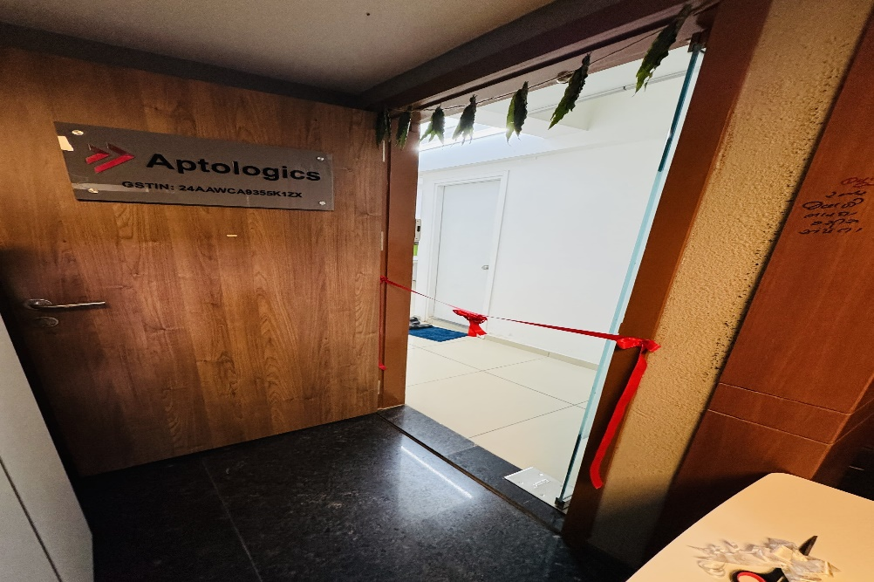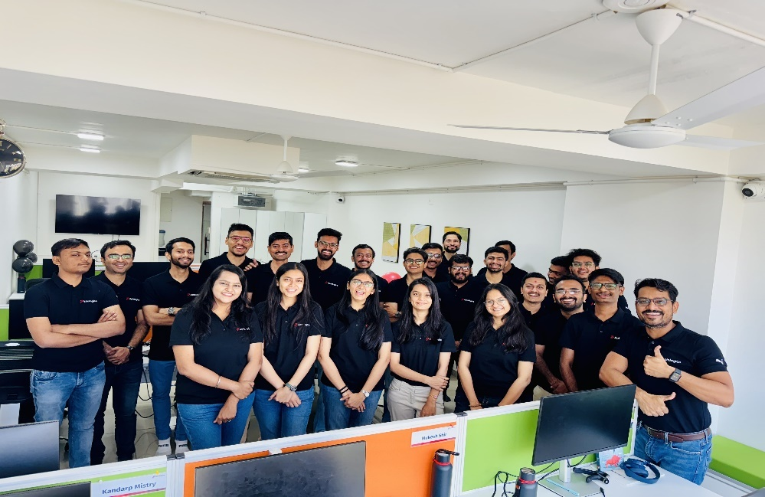

[2.3.0.1 Office Environment]

* My Company values diversity and inclusion and has a diverse workforce, including employees from different backgrounds and cultures. My Company encourages open communication and feedback, and employees are encouraged to speak up and share their ideas.
* My Company also celebrates various events, festivals and employee birthday celebration, food parties, yearly vacations etc.

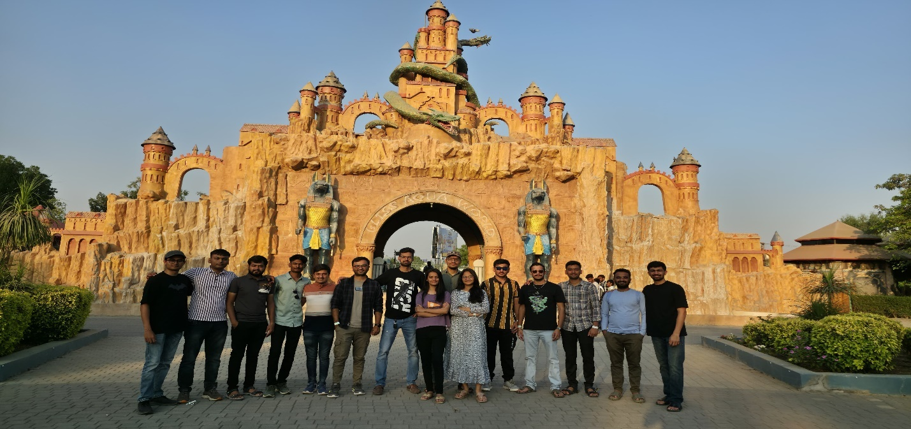

[2.3.0.3 Travel & Celebrations ]

* My Company also provides opportunities for employees to grow and develop their skills through training programs, mentorship, and career advancement opportunities. My Company promotes work-life balance and offers flexible work arrangements, such as remote work options and flexible schedules.
* Overall, My Company work environment is positive, collaborative, and focused on growth and development, while also valuing employee well-being and work-life balance.

## **Software tool’s table:**

|  |  |  |  |
| --- | --- | --- | --- |
| Index | Tool Name | Logo/Image | Use Case |
| 1. | Visual Studio Code |  | Visual Studio Code is a free coding editor that helps you start coding quickly. Use it to code in any programming language, without switching editors. Visual Studio Code has support for many languages, including Python, Java, C++, JavaScript, and more. |
| 2. | GitHub |  | GitHub is a code hosting platform for version control and collaboration. It lets you and others work together on projects from anywhere. |
| 3. | Slack |  | Slake makes it easy to contact your colleagues – you can message anyone inside or outside your organisation and collaborate just as you would in person. People can work in dedicated spaces called channels, which bring the right people and information together. |

[2.4.0.1 Software & Tools Table]

|  |  |  |  |
| --- | --- | --- | --- |
| 3. | Slack |  | Slake makes it easy to contact your colleagues – you can message anyone inside or outside your organisation and collaborate just as you would in person. People can work in dedicated spaces called channels, which bring the right people and information together. |

# Learning

**What is Software Development?**

Software development is the process of designing, coding, testing, deploying, and maintaining software applications. It involves using programming languages, frameworks, and tools to build solutions that solve real-world problems. Software development follows structured methodologies like Agile or Waterfall and often involves collaboration across teams for planning, implementation, testing, and delivery. It covers both frontend (user-facing interfaces) and backend (server-side logic and databases) aspects and ensures that the final product is secure, scalable, and maintainable.

* **Here are some of learnings of the internship :**
* **JavaScript :** Used to create interactive and dynamic web pages across all modern web applications and user interfaces.
* **TypeScript :** Provides type safety and scalable code structure for large applications, widely used in enterprise-level software and frontend frameworks.
* **React.js :** Builds modular, reusable, and dynamic user interfaces for SPAs widely used in e-commerce, SaaS, and social platforms.
* **Electron.js :** Used to create cross-platform desktop applications using web technologies, seen in tools like code editors and chat apps.
* **Git & GitHub :** Manages version control and collaborative development, essential in team-based software projects across all domains**.**Top of Form
* **Designing Fundamentals** : Bootstrap, HTML, and CSS are used to create responsive, visually appealing, and structured layouts for web applications, ensuring optimal user experience across devices.
* **Backend and Databases :** Node.js and Express.js are used to handle server-side logic and API routing, while MongoDB serves as a NoSQL database to store and manage dynamic data efficiently, ensuring scalable and secure application performance.

## **Javascript:**

JavaScript is a high-level, versatile programming language that enables the creation of interactive and dynamic features on websites. During my internship, I utilized JavaScript for implementing core logic, enhancing user interfaces, and integrating frontend behavior with backend APIs. JavaScript was an essential skill in developing responsive, user-friendly, and real-time web applications. Below are the detailed learnings and practical applications of JavaScript concepts I explored during the internship.

### DOM Manipulation :

* DOM (Document Object Model) manipulation refers to interacting with and modifying the elements of a web page using JavaScript. The DOM represents the structure of an HTML document as a tree-like model where each node corresponds to an element, attribute, or piece of text.

What I learned:

* Accessing elements using **document.getElementById(**), **querySelector(),** and **getElementsByClassName().**
* Modifying HTML content dynamically using innerHTML, textContent, and innerText.
* Changing element attributes and classes with setAttribute(), classList.add() and classList.remove().
* Dynamically creating and removing elements using createElement(), appendChild(), and removeChild().
* **Internship Applications:**
* Created dynamic property listing cards using JavaScript and DOM APIs.
* Built form validation mechanisms that provided real-time feedback without needing to reload the page.
* Implemented interactive filters (e.g., price range, location) that dynamically updated visible listings.
* Modified navigation menus based on user login status (e.g., showing logout button conditionally).

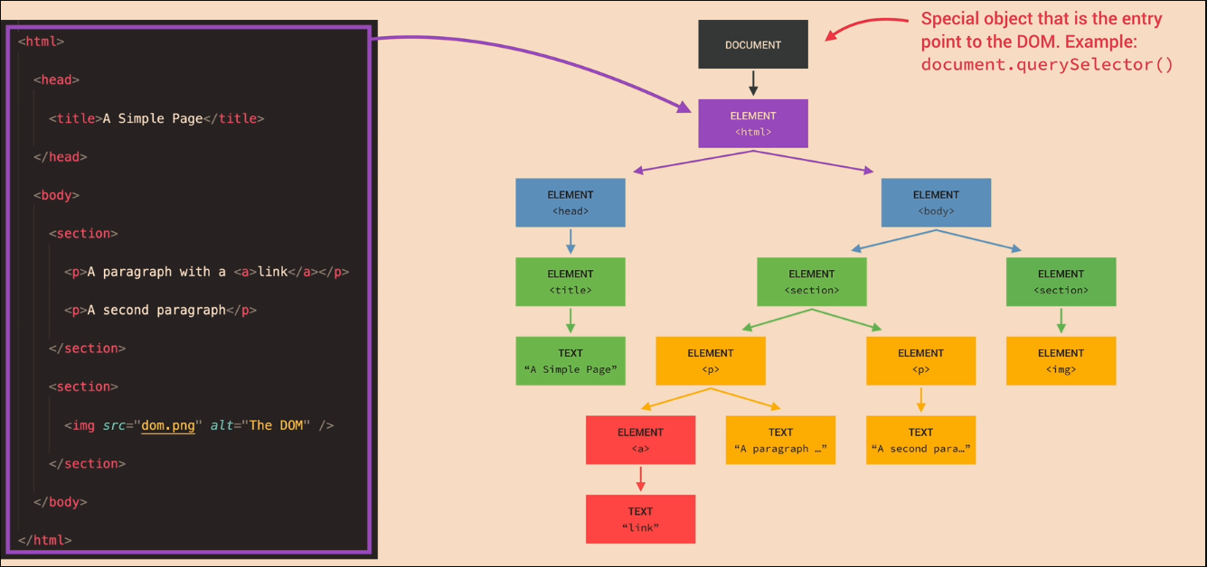

[3.1.1.1 DOM for the Html Document ]

### Asynchronous Javaacript:

Web applications must remain responsive and fast, especially when communicating with servers or APIs. Asynchronous JavaScript helps in performing time-consuming tasks like fetching data or submitting forms without freezing the browser.

**What I learned:**

* Understanding and using setTimeout() and setInterval() for timing control.
* Working with callbacks to handle results after function execution.
* Using Promises to avoid “callback hell” and simplify chaining operations.
* Implementing async and await for more readable and synchronous-looking asynchronous code.

**Internship Applications:**

* Made HTTP requests to external APIs using fetch() to retrieve property data and display it without reloading the page.
* Implemented loading spinners and UI loaders that appeared while data was being fetched or posted.
* Used asynchronous form submissions for signup, login, and review posting to enhance user experience.
* Handled server responses and errors gracefully using try...catch and .catch() blocks.

**Event Loop in Asynchronous JavaScript**

* The event loop is a fundamental part of how JavaScript handles asynchronous code execution. It is responsible for managing the execution of multiple operations by continuously checking the call stack and the callback queue.
* The call stack contains functions that are currently being executed.
* The callback queue holds functions that are ready to be executed once the call stack is empty.
* When a function (like a Promise or an event handler) completes, it is moved to the callback queue. The event loop ensures that the call stack is empty before executing the functions from the callback queue. This allows JavaScript to handle multiple operations simultaneously without blocking the main thread.

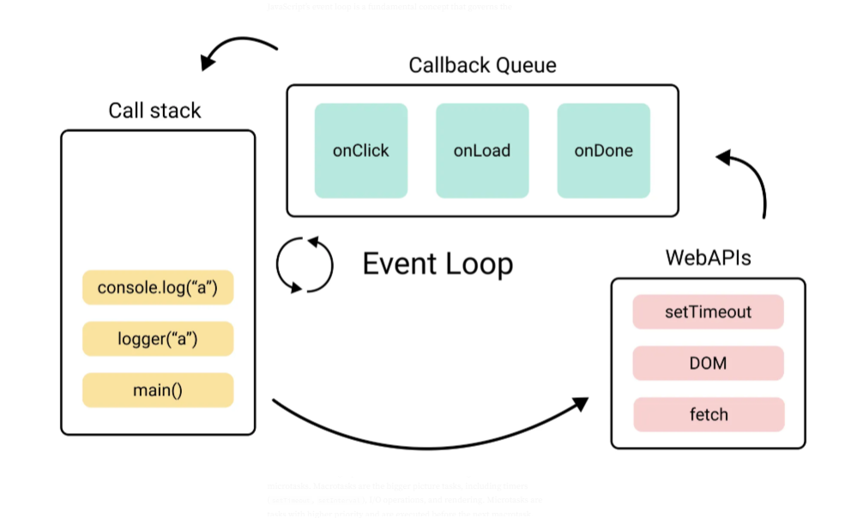

### Typescript :

TypeScript is a strongly typed superset of JavaScript that compiles down to plain JavaScript. It improves code quality, maintainability, and readability by introducing static typing and object-oriented programming features.

**What I learned:**

* Declaring variable types using string, number, boolean, any, void, and unknown.
* Creating and using interfaces to define the shape of data objects.
* Using enums for creating readable sets of related constants.
* Exploring advanced features like union types, tuples, and type inference.
* Type-checking function parameters and return values.

**Internship Applications:**

* Developed reusable UI components with well-defined TypeScript interfaces to maintain consistency across the application.
* Used TypeScript in integration with backend logic for user authentication flows.
* Caught errors at compile-time during development which helped reduce debugging time.
* Maintained cleaner and safer code while working on larger modules like listing uploads or user profile updates.

### Interfaces and Generics :

TypeScript interfaces and generics help in writing flexible and reusable code while ensuring type safety. They play a major role in structuring applications and enhancing collaboration in teams.

**What I learned:**

* Creating interfaces to define object structures.
* Using interfaces in function arguments and return types.
* Implementing generics to handle data structures like arrays and maps.
* Creating generic utility functions and components for tasks like validation or data formatting.

**Internship Applications:**

* Built a generic input validation function that works with multiple form fields.
* Used interfaces to structure API responses and ensure consistent object shapes.
* Created dynamic UI components (e.g., dropdowns, sliders) that could be reused across modules with varying data types.
* Enabled better type reuse in forms, middleware functions, and service utilities.

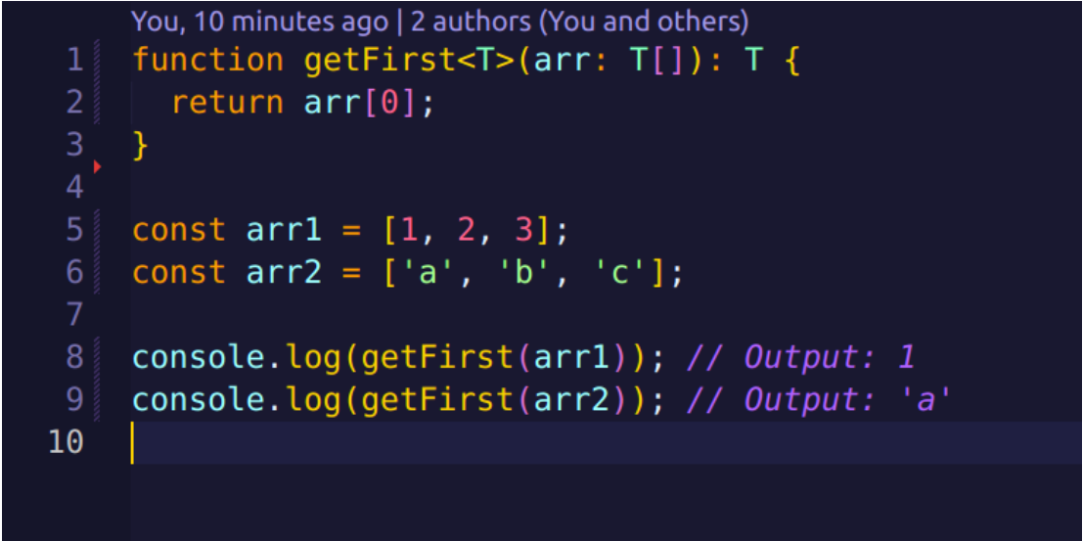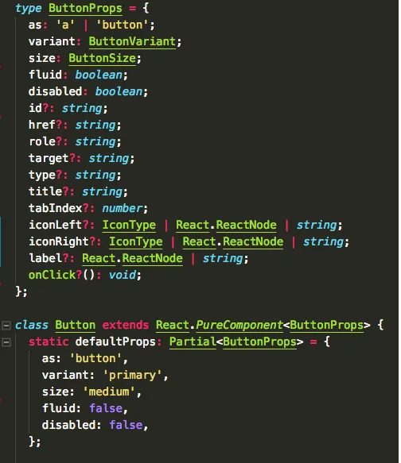

### Event Handling:

Event handling is critical in JavaScript to create interactive web applications. It allows developers to respond to user actions like clicks, key presses, form submissions, and mouse movements.

**What I learned:**

* Listening to events using addEventListener().
* Understanding event types such as click, submit, keydown, change, and mousemove.
* Handling event objects to prevent default behavior or stop propagation.
* Using event delegation to efficiently manage events in dynamically created elements.
* Managing multiple event listeners for complex UI interactions.

**Internship Applications:**

* Implemented custom modals that opened and closed based on button clicks and outside area detection.
* Created real-time feedback on forms (e.g., password match, field validation) based on input and blur events.
* Used event delegation to manage filter selection in the listing pages where multiple categories could be dynamically added.
* Enabled keyboard navigation support for accessibility using keydown and keyup handlers.

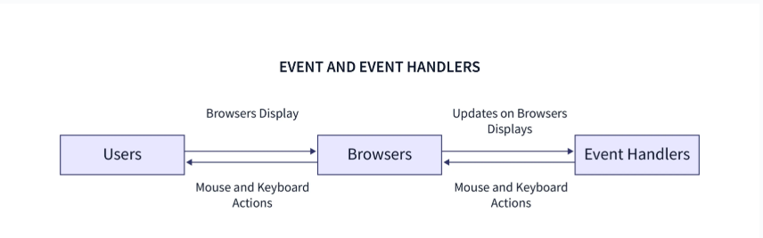

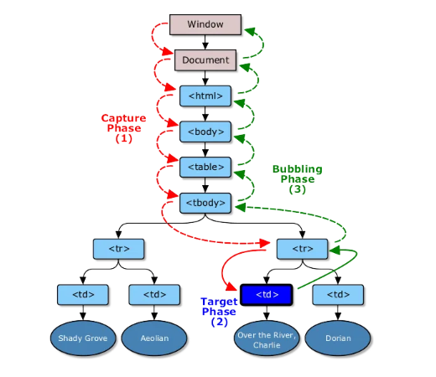

### HTML & CSS:

HTML and CSS are the foundation of any web development. HTML structures the content while CSS styles it for visual presentation. These were used throughout the internship for designing user-friendly layouts.

**What I learned:**

* Writing semantic HTML using tags like <section>, <article>, <nav>, and <main> to improve structure.
* Creating responsive layouts using Flexbox and CSS Grid.
* Styling elements with pseudo-classes like :hover, :focus, and :nth-child.
* Designing consistent themes and color schemes using variables and reusable CSS classes.
* Understanding the box model, media queries, and layering through z-index.

**Internship Applications:**

* Used Flexbox and Grid to create structured, adaptive layouts.
* Applied consistent design themes using Bootstrap classes and custom CSS.
* Implemented accessibility-focused styling practices including sufficient contrast ratios and responsive font sizes.

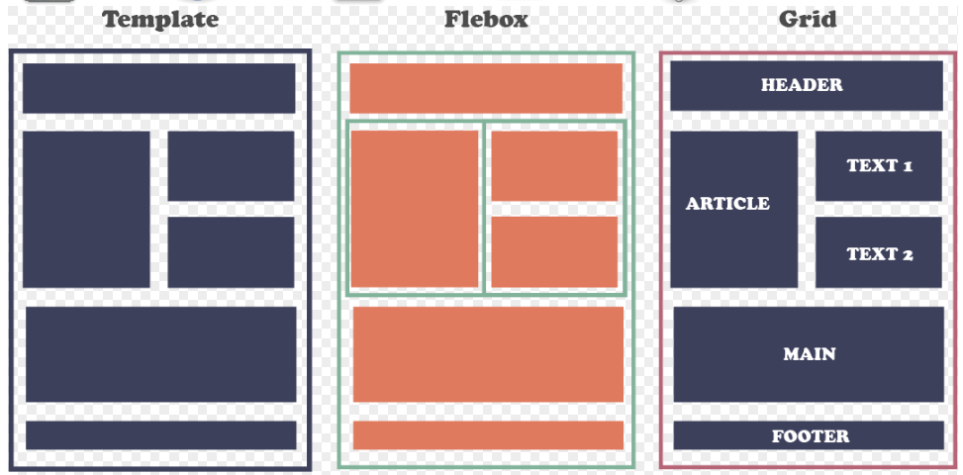

**React JS Library**

React JS is a powerful and widely-used JavaScript library for building user interfaces. It is primarily used for creating fast and interactive web applications. It enables developers to build applications that can update and render efficiently in response to data changes. Below are the key concepts of React that are fundamental in building scalable and efficient applications.

* **Component Reusability**: React allows developers to create reusable UI components, reducing development time and improving maintainability.
* **Virtual DOM for Performance Optimization**: The Virtual DOM ensures faster updates by only re-rendering parts of the UI that have changed, improving performance.
* **Strong Ecosystem and Community Support**: React has a large community and a rich ecosystem of tools and libraries, accelerating development.
* **SEO Friendly**: React can be configured for server-side rendering (SSR), making applications more SEO-friendly and improving search engine rankings.
* **Easy Integration with Other Technologies**: React seamlessly integrates with other libraries and frameworks, enabling full-stack development and efficient app building.
* As a React developer, you would primarily work with the following programming languages and technologies:
* JavaScript
* JSX (JavaScript XML)
* React Components
* React Router
* State Management (e.g., Redux, Context API)
* Hooks (e.g., useState, useEffect, custom hooks)
* HTML/CSS
* RESTful APIs and GraphQL
* Webpack/Babel for bundling and transpiling

### Components & Props:



* **Description:**
  + React is based on the concept of **components**. Components are reusable, self-contained building blocks that can be nested, managed, and rendered independently.
  + **Props** (short for properties) are used to pass data between components in React. They are read-only and are passed from parent to child components, allowing components to be dynamic and reusable.
* **Use Case in Industry:**
  + React's component-based architecture is particularly useful in building **modular** and **scalable applications**. For example, an **e-commerce website** might have a ProductCard component that receives different props (e.g., product name, price, and image) to display each product in a consistent way across the site.
  + It is widely used in large-scale applications like **social media platforms**, where the UI consists of components such as posts, comments, user profiles, etc.

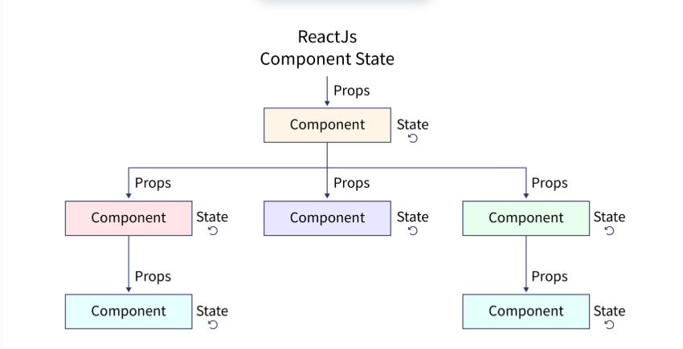

### State Management :

**Description:**

* State is an object that determines how a component renders and behaves. While props are used to pass data from one component to another, state is used to store and manage data within a component.
* When a component's state changes, it triggers a re-render, making React applications interactive and dynamic.

**Use Case in Industry:**

* React's state management is essential in building interactive user interfaces. For instance, in a social media app, the state can store data about user interactions like liking a post, commenting, or updating a user's profile.
* It's also crucial for managing dynamic data such as user inputs, form submissions, or real-time data like chat messages or live notifications.

### Hooks:

**Description**:

* Hooks are a new feature in React that allow developers to use state and other React features without writing class components.
* The most commonly used hooks include:
* **useState**: For managing local state within a functional component.
* **useEffect**: For handling side effects like data fetching, DOM manipulation, or event listeners.
* **useContext**: For accessing the global state provided by the context API.

**Use Case in Industry:**

* Hooks simplify the development of functional components, making it easier to write clean, maintainable, and reusable code.
* Data fetching in React components is often handled using useEffect combined with useState to manage loading and displaying fetched data.
* Event handling and form validations are also effectively handled using hooks, ensuring a smoother experience for users interacting with dynamic forms or interactive content.

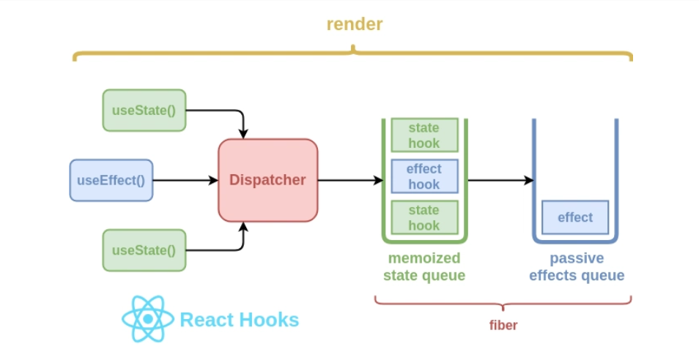

### Advanced Hooks:

**Description:**

* Advanced hooks provide additional functionality to handle complex logic in React applications:
* **useReducer:** A hook that is an alternative to useState, used for managing more complex state logic.
* **useMemo:** A hook used for memoizing expensive calculations, preventing unnecessary re-renders.
* **useCallback:** A hook that returns a memoized version of a callback function, optimizing performance.
* **useRef:** A hook that can store a mutable value, which does not trigger re-renders when changed.

**Use Case in Industry**:

* Performance optimization: Advanced hooks like useMemo and useCallback are commonly used in applications that handle large datasets or complex components to avoid unnecessary re-renders and improve performance.
* In applications where multiple state changes need to be tracked, useReducer provides a clean and scalable way to manage the state.
* Managing references in custom components, like focus management or tracking DOM elements, is commonly done using useRef.

### Redux Toolkit :

**Description**:

* Redux Toolkit is an official library that simplifies the process of using Redux for state management in React applications. Redux is used to manage the application state globally, and Redux Toolkit abstracts the complexities of Redux.
* It provides features like:
* **CreateSlice:** To automatically generate action creators and reducers.
* **Thunk middleware**: For handling asynchronous operations.
* **DevTools** integration for debugging.

**Use Case in Industry:**

* Redux Toolkit is commonly used in large-scale applications, especially where managing global state is complex. For example, an e-commerce website might use Redux to manage the user's shopping cart, user authentication, and order details.
* Redux Toolkit helps in managing the global state in applications with multiple components requiring access to the same data, such as user profiles, notifications, and app settings across various parts of the app.

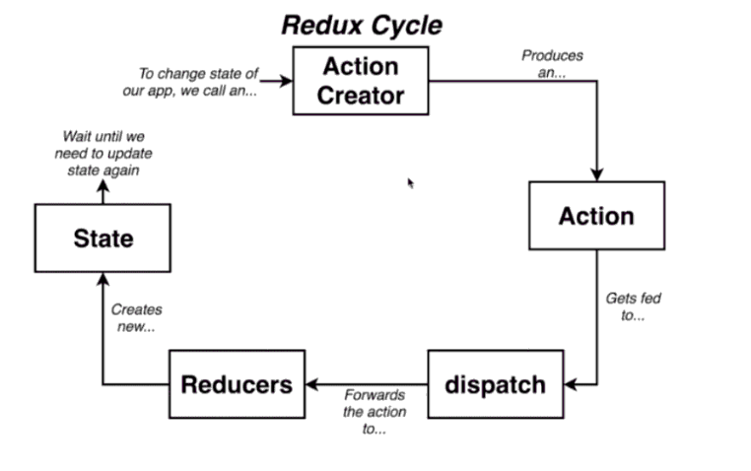

## Git & GitHub:

Git and GitHub are essential tools in modern software development that help manage source code, track changes, collaborate with teams, and maintain the integrity of projects over time.

### **Version Control:**

* Version control allows developers to track and manage changes to code over time.
* Git is a distributed version control system that enables efficient branching, merging, and collaboration.
* It ensures rollback to previous versions in case of errors or issues during development.
* Enables multiple developers to work on the same project simultaneously without conflict.
* Helps maintain a history of changes, making it easier to audit and debug codebases.



### **Git :**

Git is the core version control system used for tracking source code changes.

Common Git Commands:

**git init** – Initializes a new Git repository.

**git clone <repo-url>** – Clones a remote repository to your local system.

**git add .** – Adds all changes in the current directory to the staging area.

**git commit -m "message"** – Commits staged changes with a message.

**git status** – Shows the current status of changes in the working directory.

**git log** – Displays the commit history.

**git branch** – Lists all local branches.

**git checkout <branch>** – Switches to the specified branch.

**git merge <branch>** – Merges the specified branch into the current one.

**git pull** – Fetches and integrates changes from a remote repository.

**git push** – Uploads local changes to a remote repository.

**Advanced Git Concepts**:

* **Branching:** Enables feature development in isolation before merging to the main codebase.
* **Rebase vs Merge**: Rebase maintains a cleaner history; Merge retains complete history.
* **Stashing:** Temporarily shelves changes with git stash without committing.
* **Cherry-Pick:** Apply specific commits from one branch to another with git cherry-pick.
* **Git Hooks:** Scripts that run automatically on certain git events (like commit, push).

### **Github:**

* GitHub is a cloud-based hosting service that manages Git repositories and supports team collaboration.
* Offers pull requests for code review and merging branches.
* Enables issue tracking, project management, and continuous integration workflows.
* Supports GitHub Actions for automating build, test, and deployment pipelines.
* Provides access control and collaboration tools like forks, stars, and watchers.
* Allows integration with third-party services like Slack, Trello, and CI/CD tools.

**Key GitHub Features:**

* **Pull Requests**: Enable collaboration and review before code is merged.
* **Issues**: Track bugs, features, and enhancements.
* **Actions**: Automate workflows such as testing and deployment.
* **Forking**: Allows creating personal copies of repositories to experiment freely.
* **Releases**: Mark stable versions of the codebase for production use.

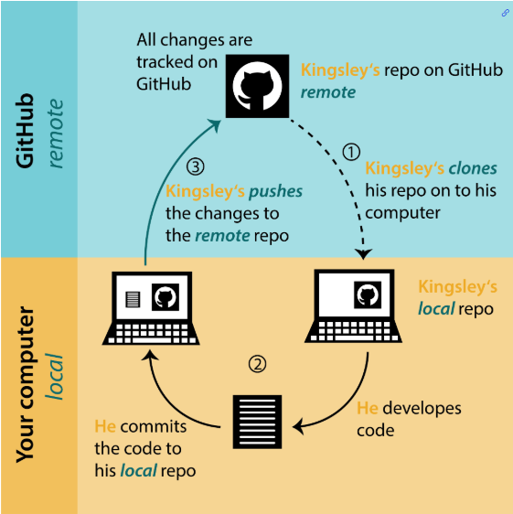

## **Bootstrap :**

Bootstrap is a widely-used open-source front-end framework for developing responsive and mobile-first websites. It includes HTML, CSS, and JavaScript-based design components that help developers quickly build modern, clean, and consistent user interfaces.

**Bootstrap Overview**

* Bootstrap is used for designing responsive and visually appealing web pages efficiently.
* It provides a comprehensive library of ready-to-use components like buttons, modals, navbars, forms, and cards.
* It follows a mobile-first approach, ensuring websites are optimized for all screen sizes.
* Reduces the need to write custom CSS by offering a large set of utility classes
* Speeds up development time and ensures design consistency across all pages.

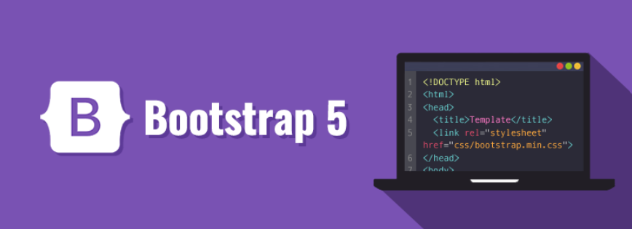

### **Design Template:**

* Created multiple design templates using Bootstrap grid and utility classes.
* Utilized Bootstrap’s responsive layout system (.container, .row, .col) for structuring content.
* Integrated pre-built components such as carousels, accordions, and alert boxes to enhance interactivity.
* Customized themes by overriding Bootstrap variables and using SASS support.
* Followed modular design by separating sections into reusable UI components.

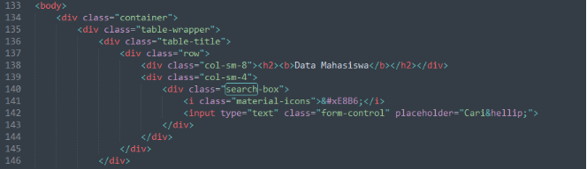

### **Website : 1:** **Ebook Website**

**Features :**

* Modern layout with custom colors/styles/backgrounds
* Responsive design , Sticky navbar with style changes on scroll
* Bootstrap modals , Form & input styles , Testimonials ,Contact page with Google Map

Deployed On Vercel : <https://ebook-website-six-ruby.vercel.app/>

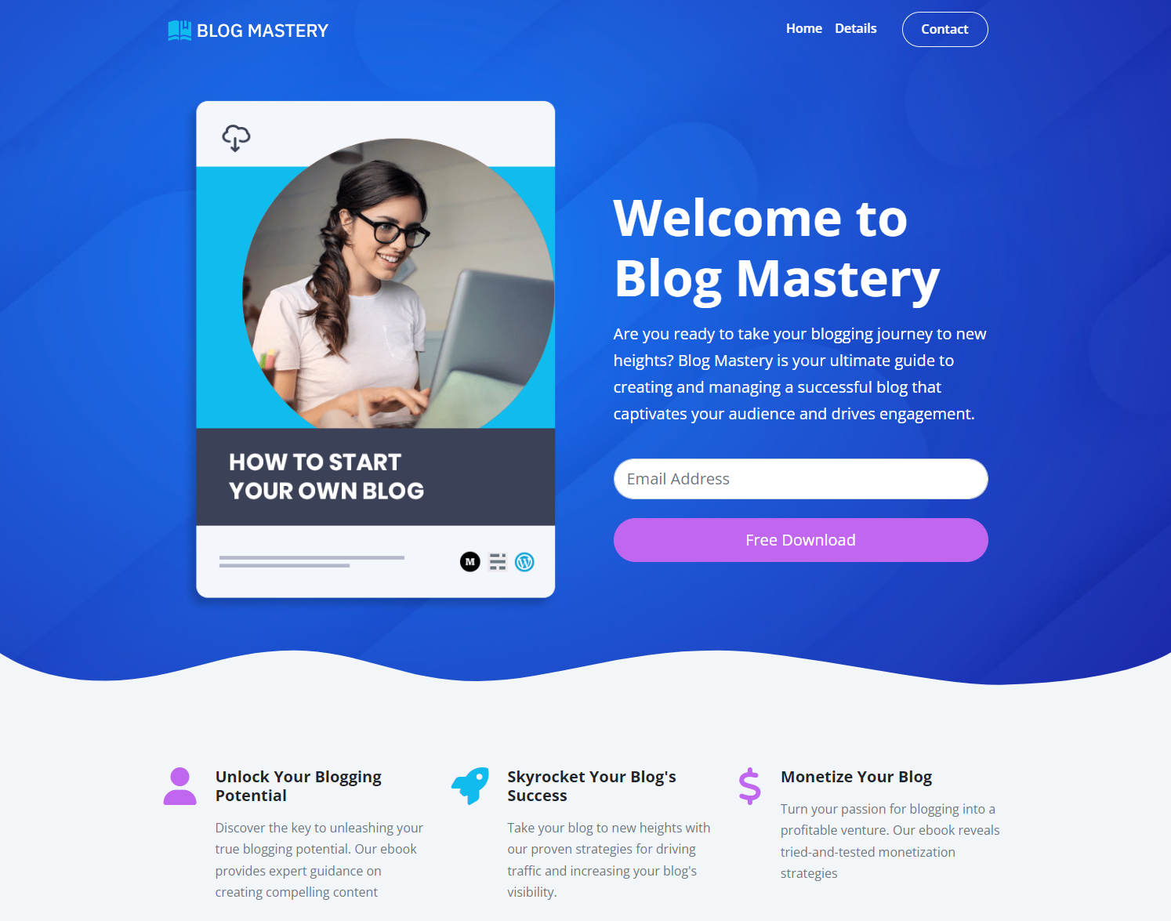

### **Website : 2:** **Vera Website**

* Bootstrap Business website for software solutions, but could easily be changed to fit any business. Dark-themed design with modals and other features.

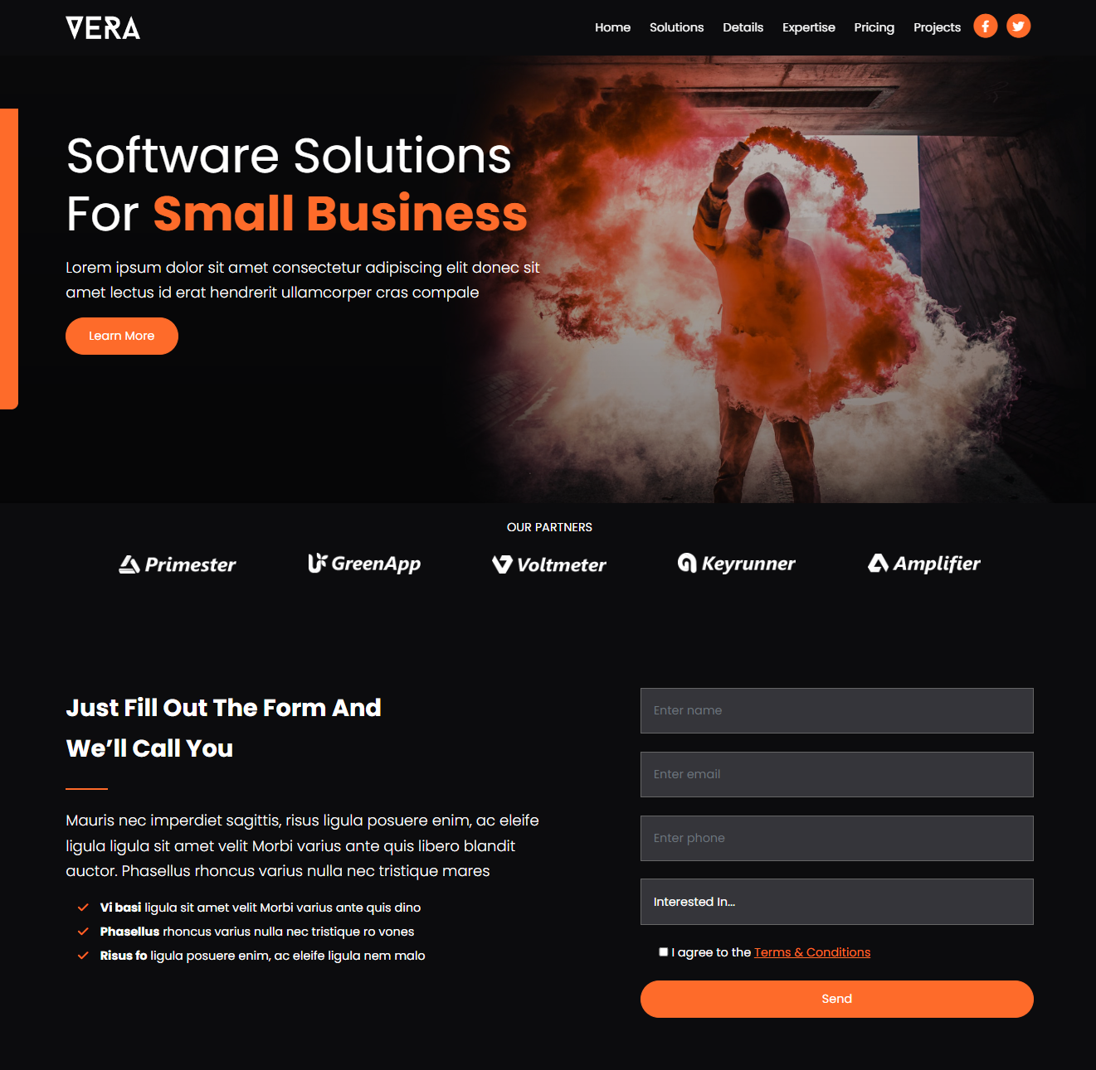

## Backend & Database:

In modern web development, backend technologies and databases play a crucial role in building scalable and efficient applications. During the internship, hands-on experience was gained in developing RESTful APIs, managing databases, and following structured backend architecture using Node.js, MongoDB, and the MVC (Model-View-Controller) design pattern.

### **Node Js :**

* Node.js is a runtime environment that allows executing JavaScript on the server side.
* It is built on the V8 JavaScript engine, providing high performance and scalability.
* Used for handling asynchronous operations through callbacks, promises, and async/await.
* Ideal for building lightweight, fast, and scalable applications due to its event-driven architecture.
* Applied in the internship to handle backend logic, server creation, and data operations.
* Common modules like express, path, dotenv, and mongoose were used to enhance functionality.
* Node.js was also used for handling routing, middleware, and server configurations.

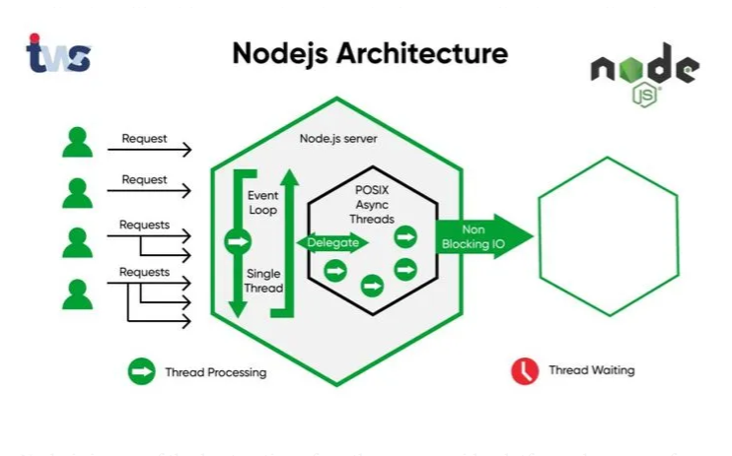

### **API Design:**

* APIs (Application Programming Interfaces) allow different parts of a system to communicate.
* **RESTful APIs** were built using Express.js, a Node.js framework for routing and middleware.
* Developed endpoints for **CRUD** (Create, Read, Update, Delete) operations on listings and reviews.
* Followed standard REST principles for URL structuring and HTTP methods (GET, POST, PUT, DELETE).
* Implemented API authentication and authorization using **JWT (JSON Web Tokens)** and PassportJS.
* Error handling was implemented using custom middleware and helper utilities like wrapAsync and ExpressError.

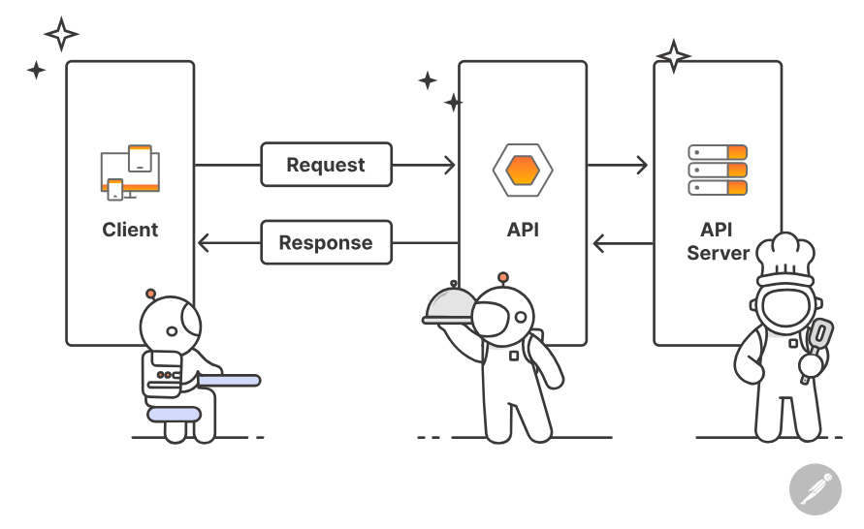

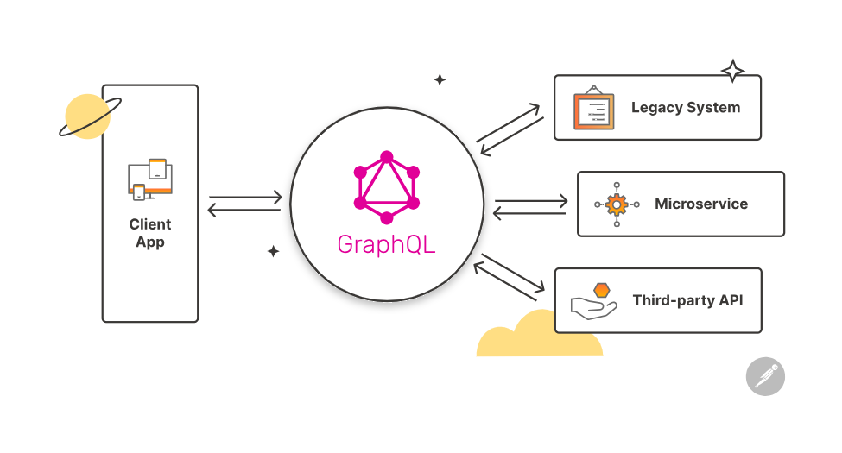

### **Mongo DB:**

* MongoDB is a NoSQL database that stores data in flexible, JSON-like documents.
* Preferred for its schema-less structure, scalability, and ease of use with JavaScript environments.
* Used to manage and persist data such as user profiles, listings, and reviews.
* Integrated into the application using the Mongoose ODM (Object Data Modeling) library.
* Mongoose schemas were used to define data structure, validation, and relationships (e.g., one-to-many between users and listings).
* Features like indexing, population (for related documents), and middleware hooks were explored.
* Data operations (e.g., .find(), .save(), .updateOne(), .deleteMany()) were commonly used.

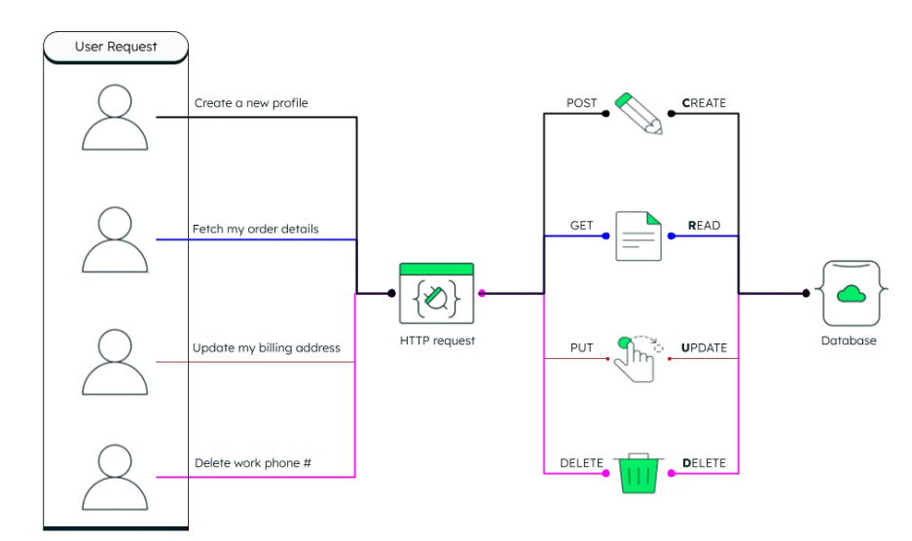

**Additional Tools & Practices Used:**

* **Postman**: For testing API endpoints during development.
* **Dotenv**: For managing environment variables securely.
* **Middleware**: Used for handling errors, user sessions, and request validation.
* **Cloudinary**: Used in integration with MongoDB for storing media files (e.g., images of listings).
* **Session** & **Flash**: Utilized session management and flash messaging for better UX in user interactions.

### **MVC Architecture:**

* The MVC architecture was followed for clean code separation and maintainability.
* Model: Defined using Mongoose schemas for Listings, Users, and Reviews. Handled data validation and database operations.
* View: Built with EJS templates to render dynamic and reusable HTML pages.
* Controller: Managed application logic, routing, and interaction between models and views.
* Additional Points:
* Simplified debugging by isolating issues to specific layers.
* Made it easier to scale the app by adding new features without affecting existing code.
* Promoted teamwork by allowing developers to work on different parts (models, views, controllers) independently.
* Helped organize middleware and route handling cleanly.

# 

**Project 1 : Real Time Chat App using Electron Js**

### **Electron Js Intro:**

Electron JS is a popular open-source framework that enables developers to build cross-platform desktop applications using standard web technologies such as HTML, CSS, and JavaScript. It combines the Chromium rendering engine and Node.js runtime, providing access to both web-based front-end rendering and back-end server capabilities in a single runtime environment.

Electron allows developers to:

* Build native applications without needing platform-specific code.
* Integrate Node.js features (file systems, process handling, etc.) into a desktop environment.
* Package web apps as desktop applications with access to system resources.

This makes Electron ideal for creating apps like Slack, Visual Studio Code, and our Real-Time Chat Application, which benefit from both a responsive UI and native OS capabilities.

**IPC Communication**

In Electron, applications are split into two types of processes:

**Main Process:**

* Controls the application’s lifecycle, manages native UI elements like windows and menus, and has full access to Node.js APIs.

**Renderer Process:**

* Runs the UI for each window and functions like a regular web page (HTML, CSS, JavaScript). It has limited access to Node.js for security reasons.

**Why IPC is Needed:**

* Direct access between the main and renderer processes is restricted for security and architectural clarity. To allow controlled communication, Electron provides IPC (Inter-Process Communication) channels.

IPC Modules:

**ipcMain:**

* Used in the main process to listen for and handle events/messages sent by renderer processes.

**ipcRenderer:**

* Used in the renderer process to send asynchronous messages to the main process or listen for replies.

**Use Case in a Chat App:**

* User sends a message from the renderer (chat window).
* The message is sent to the main process via ipcRenderer.send().
* The main process receives the message, processes it (e.g., saves to database or forwards to other users).
* The message is then broadcast back to other renderer windows for display using webContents.send().

**Example Code :**

// Renderer Process

ipcRenderer.send('chat:sendMessage', message);

// Main Process

ipcMain.on('chat:sendMessage', (event, message) => {

mainWindow.webContents.send('chat:displayMessage', message);

});

**Additional Notes:**

* You can also use ipcRenderer.invoke() and ipcMain.handle() for Promise-based IPC (better for request/response patterns).
* For enhanced security, always validate data in the main process before processing.
* Electron recommends enabling context isolation and using a preload script to expose only safe APIs to the renderer.

**Foldar Strcurure: This is Final folder structure of chat Management app**

**electron-chat**

* **assets/ → images**
* **resources/**
* **src/**
* **js/**
* **actions/ (app.js, auth.js, chats.js, etc.)**
* **api/ (auth.js, chats.js, connection.js)**
* **components/ (LoginForm, Messenger, Navbar, shared/)**
* **db/ (firestore.js)**
* **layouts/ (Base.js)**
* **reducers/ (auth.js, chats.js, etc.)**
* **store/ (middlewares/, StoreProvider.js)**
* **utils/ (notifications.js, storage.js, time.js)**
* **views/ (Chat.js, Home.js, Settings.js, App.js, index.js, etc.)**
* **utils/ (Menu.js)**
* **Other files:**
* **index.html, main.js, preload.js**
* **splash.css, splash.html**
* **package.json,webpackconfigs,.gitignorewebpack.prod.js**

**Preload Scripts & Context Bridge**

* To allow secure communication between the renderer and main processes while using context isolation, Electron introduces Preload Scripts and Context Bridge.

**Preload Script:**

* It runs in a separate environment before the web page loads.
* It has access to both DOM (like a renderer) and Node.js APIs (like the main process).
* Acts as a bridge to expose only the necessary APIs to the renderer.

**Context Bridge:**

* A module in the preload script that exposes selected APIs from the preload to the renderer using contextBridge.exposeInMainWorld.

// preload.js

const { contextBridge, ipcRenderer } = require('electron');

contextBridge.exposeInMainWorld('chatAPI', {

sendMessage: (msg) => ipcRenderer.send('chat:sendMessage', msg),

onMessage: (callback) => ipcRenderer.on('chat:displayMessage', (event, msg) => callback(msg)),

});

// renderer.js

chatAPI.sendMessage('Hello');

chatAPI.onMessage((msg) => {

// Update chat UI

});

* This design enforces security while maintaining functionality—a key best practice for modern Electron apps.

**Window Management & Chat Communication**

* The main window is created using Electron’s BrowserWindow class.
* Custom settings like window size, resizability, and preload script attachment are configured in the main process.
* The HTML/CSS UI is rendered in the renderer process.
* Chat messages are dynamically updated using JavaScript DOM manipulation.
* Styling and layout are handled using CSS and Bootstrap for a responsive, modern look.

// main.js

const mainWindow = new BrowserWindow({

width: 800,

height: 600,

webPreferences: {

contextIsolation: true,

preload: path.join(__dirname, 'preload.js')

}

});

### **Images of the Chat App**:

**Key Features of the Chat Application :**

* Real-time messaging using IPC communication.
* Secure architecture using Context Isolation and Context Bridge.
* Modern, clean UI with HTML, CSS, and Bootstrap.
* Window and session management using Electron’s APIs.
* Modular structure separating UI, preload, and main logic.
* Utilized functionality of React Redux toolkit for effective state Management
* Firebase as database to effectively store and retrive user data
* Securely provides Authentication for user
* Effectively handles errors .

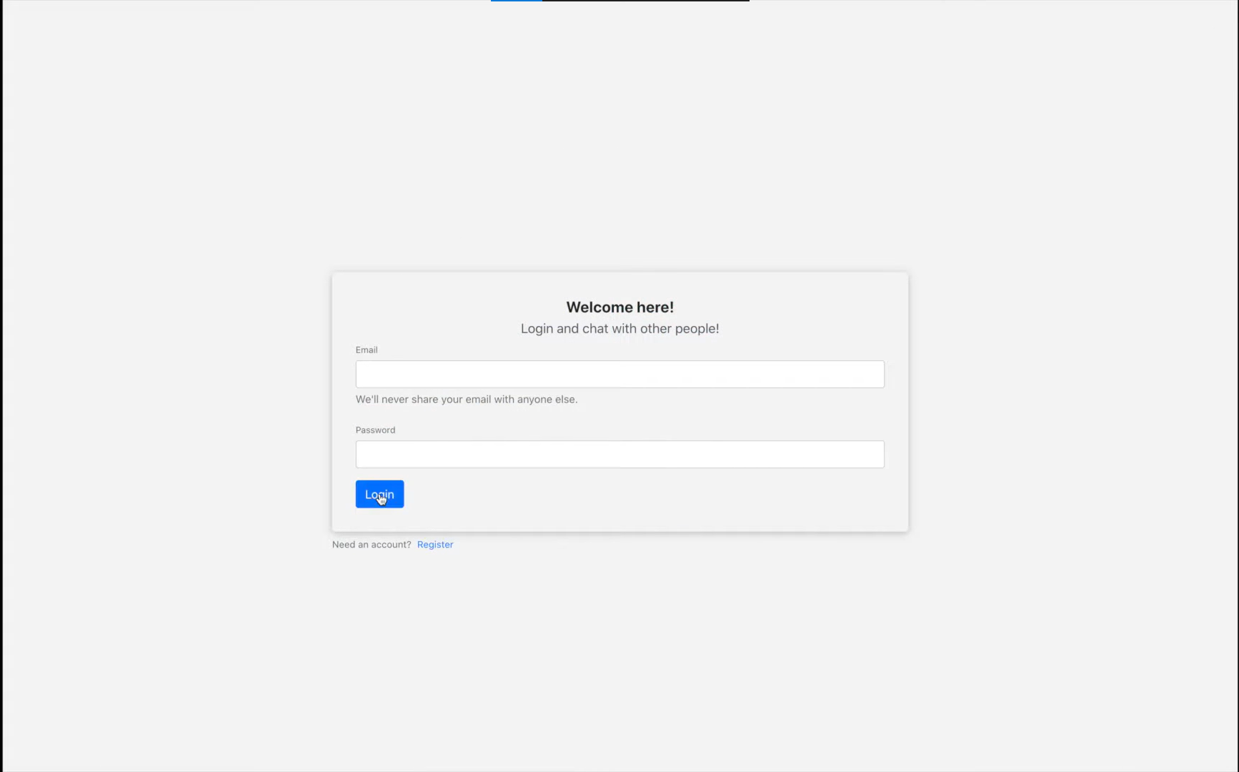

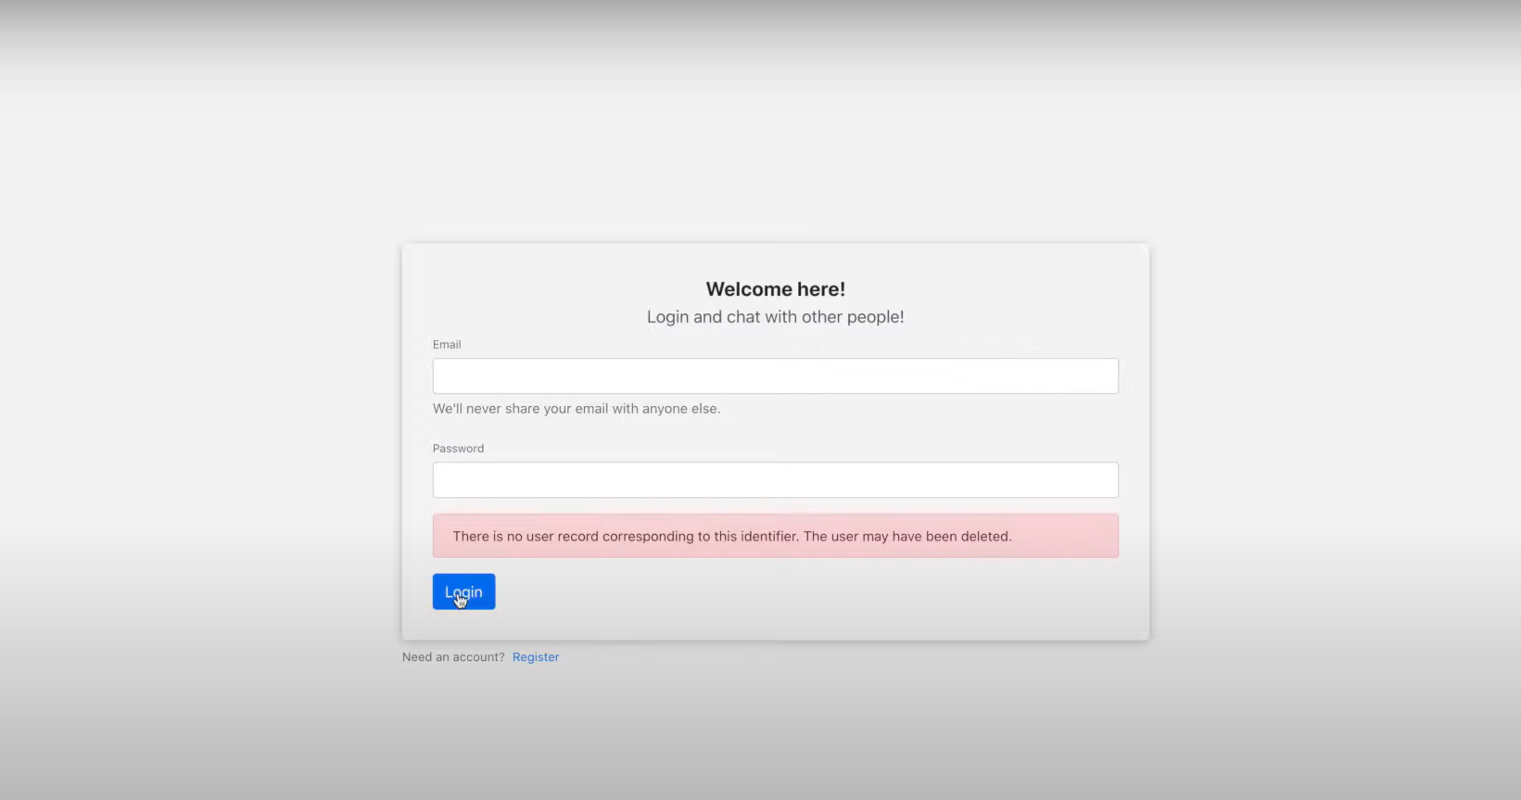

* User is able to create channel and Join chat on the respective channel and communicate .

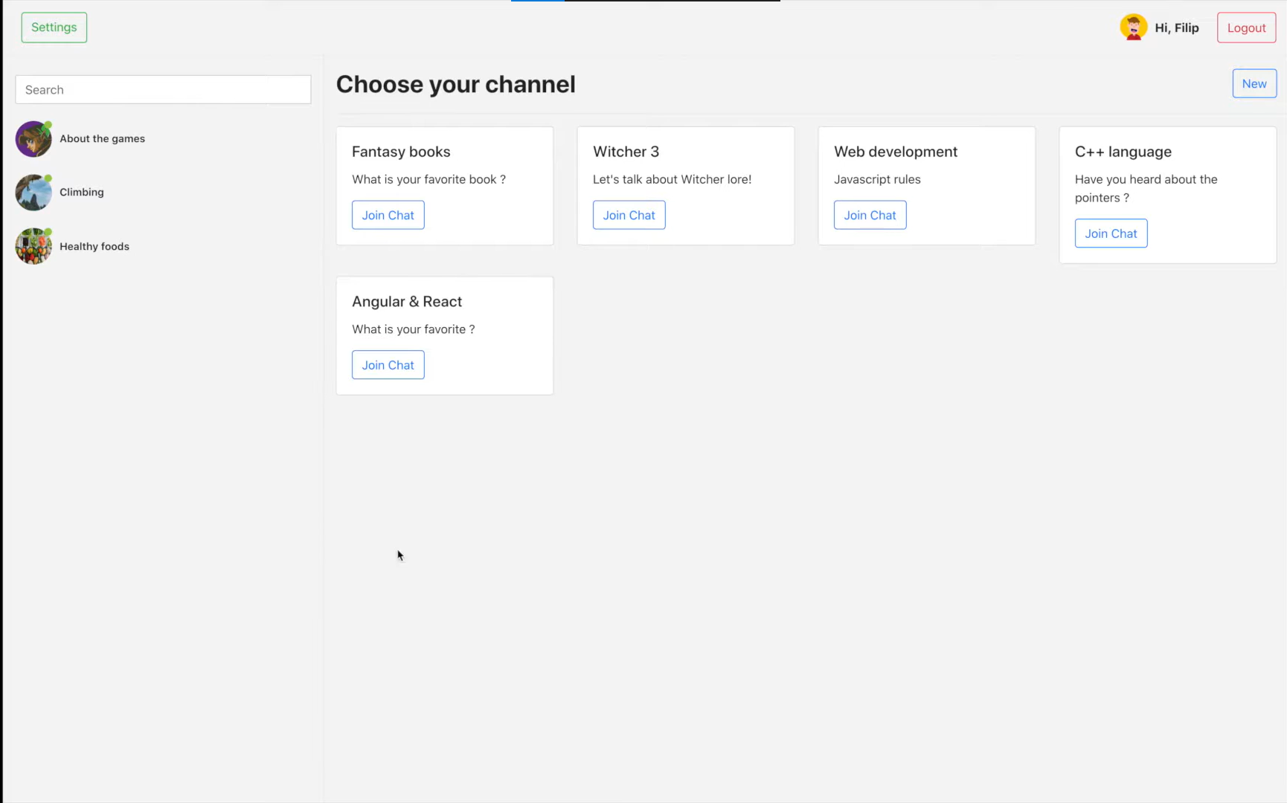

* User can Modify settings as per the Requirement

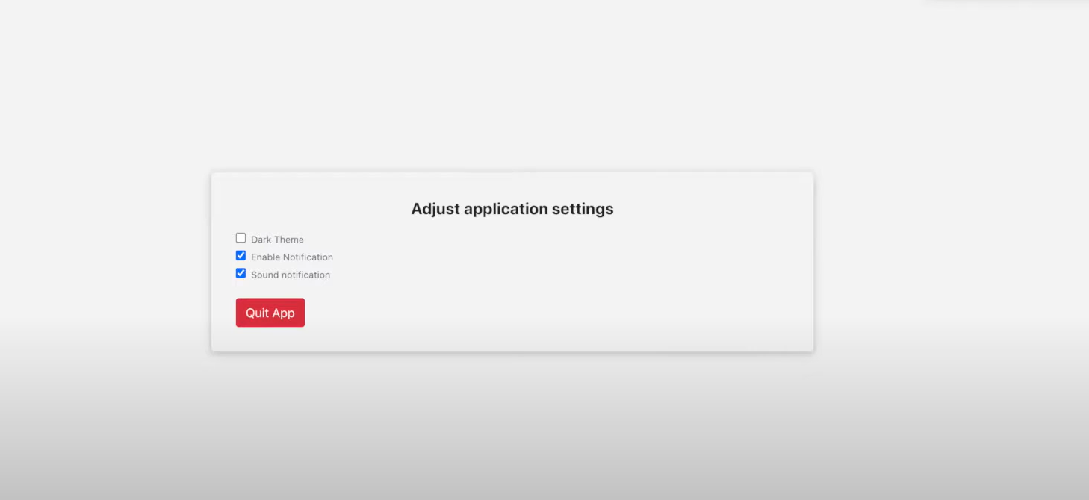

* Notification Feature when some unusual behaviour happens

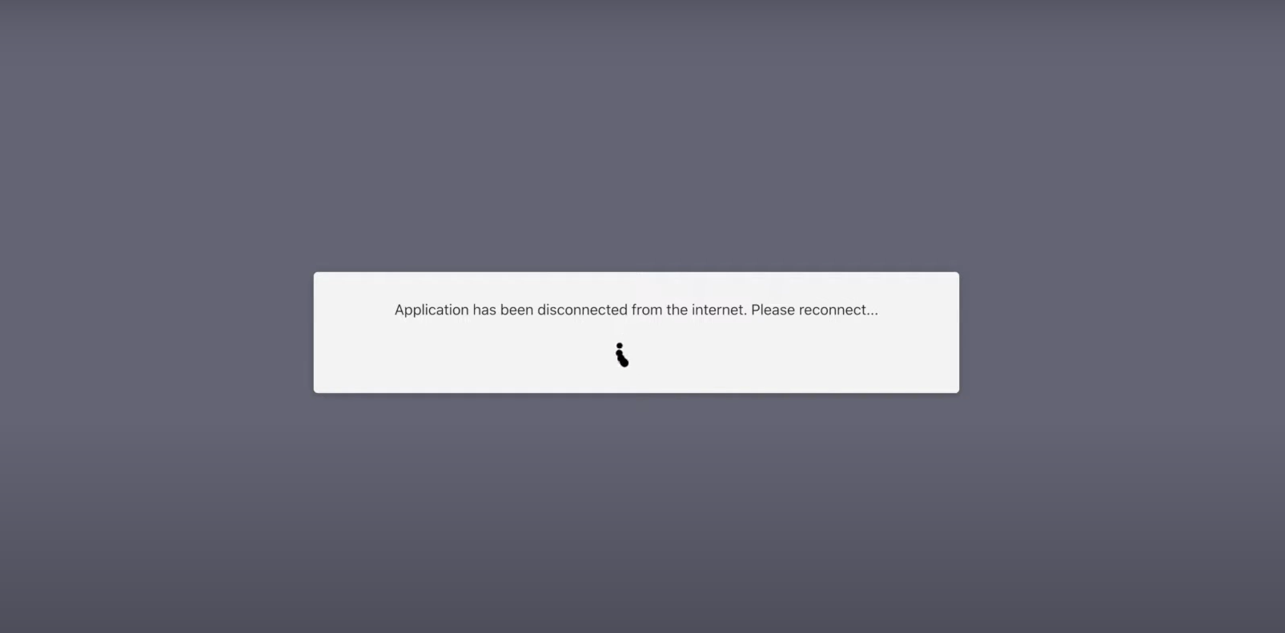

* Create Chat interface :

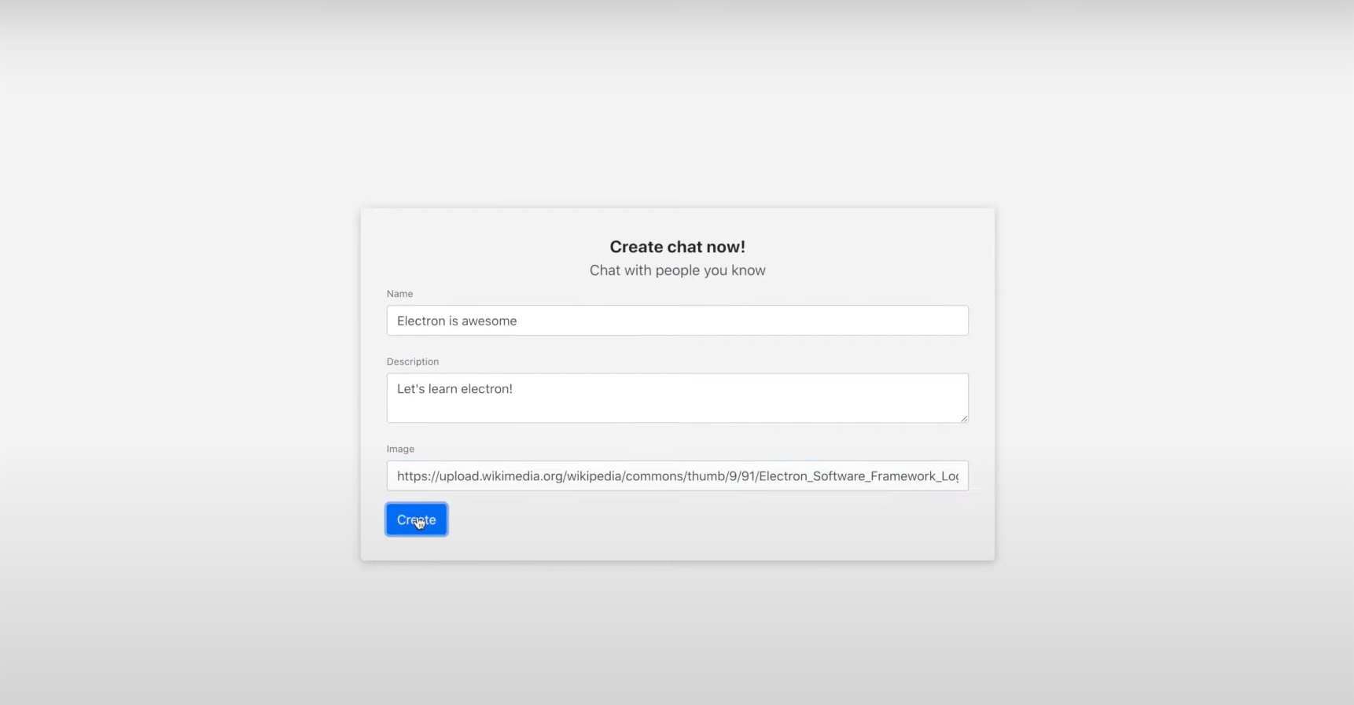

# User Is able to chat in Realtime using IPC

# 

# Can change theme of the desktop

# 

**Project 2 : Wanderlust**

### **Introduction & Objective:**

Wanderlust is a full-stack web application developed to facilitate online property rental and booking services, similar to platforms like Airbnb.

It allows users to explore listings, post new properties, and leave reviews for others. The primary goal of the application is to deliver a seamless and secure platform for both hosts and travelers with a responsive and intuitive UI.

### **Tech Stack Overview:**

Wanderlust employs the following technologies and tools:

➤ **Frontend**:

**EJS (Embedded JavaScript Templates):** Templating engine to dynamically render HTML pages.

**Bootstrap**: Used for responsive and mobile-first design.

**Custom CSS**: For additional styling and UI refinement.

➤ **Backend**:

**Node.js**: Event-driven, non-blocking I/O runtime for server-side logic.

**Express.js:** Web framework for Node.js to handle routing, middleware, and APIs.

➤ **Database**:

**MongoDB (Atlas):** NoSQL cloud database to store user data, listings, and reviews.

**Mongoose:** ODM for MongoDB for schema modeling and query building.

➤ **Authentication & Security**:

**Passport.js**: Middleware for authentication using the Local Strategy.

**express-session & connect-mongo**: To maintain user sessions with persistence in MongoDB.

➤ **Other Tools:**

**Cloudinary:** Cloud-based service for image uploads and transformations.

**Dotenv:** Environment variable management.

**Project Features :**

* User Registration and Secure Login
* Property Listings CRUD (Create, Read, Update, Delete)
* Review and Rating System
* Cloud Image Upload
* Role-based access control
* Form validation and error handling
* Responsive layout and search filters
* **SignUp Page UI :**
* The **Signup Page** allows new users to create an account on the platform. The user enters their **name**, **email**, and **password**. Once the data is submitted, it is processed and stored in a **secure MongoDB** database using the **bcrypt** hashing algorithm to ensure passwords are stored safely. The system uses **Passport.js** for **local authentication** which ensures that only users who have signed up successfully can log in.
* The system uses **validation** to ensure that the email is unique, and the password meets security standards. Upon successful registration, the user is redirected to the **login page**, where they can authenticate using their credentials. If there's an error, such as an existing email, an error message is displayed.

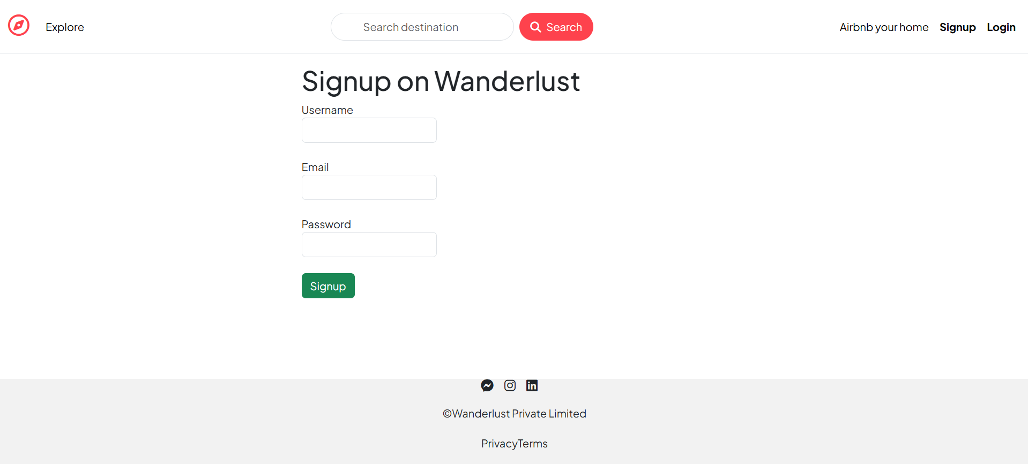

### **Login Page UI**

* The **Login Page** allows registered users to access their accounts securely. Users enter their **email** and **password**, which are verified against the **MongoDB database**. If the login credentials are correct, the user is granted access to the platform. If the credentials do not match, the user is notified with an error message.
* The page utilizes **Passport.js** for authentication, specifically the **local strategy**, to validate the entered credentials and initiate a session. Sessions are managed using **express-session**, and user data is stored in the session for persistent login across the application. If the user is successfully authenticated, they are redirected to the **dashboard** or home page.

### 

### **MVC Architecture:**

* The project follows the Model-View-Controller design pattern:
* **Model:** Represents data objects like users, listings, and reviews using Mongoose.
* **View:** EJS-based templates render dynamic content using layouts and partials.
* **Controller:** Handles the logic behind user requests and interacts with the model

Example:

listing.js (Controller) → Fetches data from Listing model and renders views/listings/show.ejs.

### **Folder Structure Explanation:**

**wanderlust/**

**├── controllers/**

**│ ├── listing.js**

**│ ├── review.js**

**│ └── user.js**

**├── models/**

**│ ├── listing.js**

**│ ├── review.js**

**│ └── user.js**

**├── routes/**

**│ ├── listing.js**

**│ ├── review.js**

**│ └── user.js**

**├── views/**

**│ ├── listings/**

**│ ├── users/**

**│ ├── includes/**

**│ └── layouts/**

**├── utils/**

**│ ├── ExpressError.js**

**│ └── wrapAsync.js**

**├── public/**

**│ └── css/style.css**

**├── cloudConfig.js**

**├── app.js**

**└── schema.js**

* **controllers/**  
  The **controller** layer is responsible for handling the application's business logic. It processes requests, interacts with the model, and determines what response to send back to the user.
* **listing.js**: Contains functions to manage listing-related actions, such as creating, updating, deleting, or retrieving listings.
* **review.js**: Contains functions for handling reviews, like adding or deleting a review for a specific listing.
* **user.js**: Handles user-related actions such as user registration, login, and profile management.
* **models/**  
  The **model** layer represents the data structure and interacts with the database. It defines how data is stored and validated using Mongoose schemas.
* **listing.js**: Defines the Mongoose schema for listings, which might include fields like title, description, price, etc.
* **review.js**: Defines the Mongoose schema for reviews, including the review's content, rating, and the listing it belongs to.
* **user.js**: Defines the schema for user data, such as username, email, and password (usually hashed).
* **routes/**  
  The **routes** layer defines the API endpoints or URL routes and maps them to specific controller functions. Each route handles an HTTP request (GET, POST, etc.) for a specific resource.
* **listing.js**: Contains routes related to listings, such as viewing, adding, or deleting a listing.
* **review.js**: Contains routes for review-related actions, like posting a new review or deleting an existing one.
* **user.js**: Contains routes for user-related actions, such as registering a new user or logging in.
* **views/**  
  The **view** layer is responsible for rendering the frontend of the application. It contains EJS templates that are rendered on the server and sent as HTML to the client.
* **listings/**: Contains view templates related to displaying listings, such as individual listing pages or the listings overview page.
* **users/**: Contains templates related to user actions like login and signup forms, user profile pages, etc.
* **includes/**: Contains partial EJS templates that are included in other views, such as headers, footers, and navigation bars.
* **layouts/**: Defines base layout templates that are used for all views, ensuring a consistent page structure (e.g., HTML boilerplate, head tags, etc.).
* **utils/**  
  Utility files provide reusable helper functions or custom error handling. These can be used across the entire application to simplify code.
* **ExpressError.js**: A custom error-handling class that makes it easier to manage application errors. It can be used to throw and handle errors in a consistent manner.
* **wrapAsync.js**: A helper function that wraps asynchronous functions to catch errors in Express routes. This helps avoid repetitive try-catch blocks.
* **public/**  
  The **public** folder contains static files like CSS, JavaScript, and images that are publicly accessible to users. These assets are served by Express directly.
* **css/style.css**: Contains styles for the frontend, like layout, typography, colors, and responsive design.
* **cloudConfig.js**  
  Contains configuration settings for cloud services like AWS S3 or cloud storage, if your application is storing or managing files (such as images or documents) on the cloud.
* **app.js**  
  The main application entry point for the Express server. It contains the setup for middleware (like body parsers, session handling), connects the routes, and starts the server.
* **schema.js**  
  This file typically holds additional database schema definitions or utility functions related to schema design. It may also include data validation rules for MongoDB collections.

### **Authentication & Authorization:**

Authentication and authorization in the application are handled using **Passport.js** with the **Local Strategy**. This setup ensures that users can securely register, log in, and access protected routes.

#### **Registration & Login:**

* **Registration:** Users can register with their **name**, **email**, and **password**. The password is **hashed** using **bcrypt** before being stored in the database to ensure security.
* **Login:** During login, users provide their **email** and **password**. Passport.js's **Local Strategy** compares the entered password with the stored hashed password and, if valid, establishes a **session** for the user.

#### **Session Management:**

* Sessions are maintained using **express-session**, which creates a session cookie in the user’s browser.
* The session is stored in **MongoDB** using **connect-mongo**, ensuring that users remain logged in across sessions.

#### **Protected Routes:**

* **isLoggedIn Middleware:** Ensures that only authenticated users can access certain routes. If a user is not logged in, they are redirected to the login page.
* **isAuthor Middleware:** Prevents unauthorized users from editing or deleting a listing. This middleware ensures that only the **creator** of a listing can make changes to it.

#### **Authorization Flow:**

* When a user signs up or logs in, a session is created and stored.
* On accessing a protected route, the session is checked to verify the user’s authentication status.

### **Middleware and Utilities:**

➤ Custom Middleware:

* isLoggedIn – Auth check for protected routes.
* isAuthor – Checks listing ownership.
* validateListing & validateReview – Uses Joi schemas for validating form input.

➤ Utility Functions:

* wrapAsync: Catches async errors and forwards to the error handler.
* ExpressError: Custom error class for centralized error management.

**Screenshots & Output Pages**

**Create Listing Page UI**

The **Create Listing Page** allows authenticated users (those who are logged in) to post new property listings. The form accepts details such as the **title**, **description**, **price**, **location**, and **images**. Images are uploaded to **Cloudinary**, which provides a secure and efficient way to store and manage user images.

The **form validation** is done using **Joi** to ensure all required fields are filled in. Users are also allowed to upload **multiple images** for a single property. Once the listing is created, it is stored in the **MongoDB database** under the **listings** collection and becomes visible to other users in the **View Listings** section.

User also can upload image of the property this feature is implemented using cloudinary.

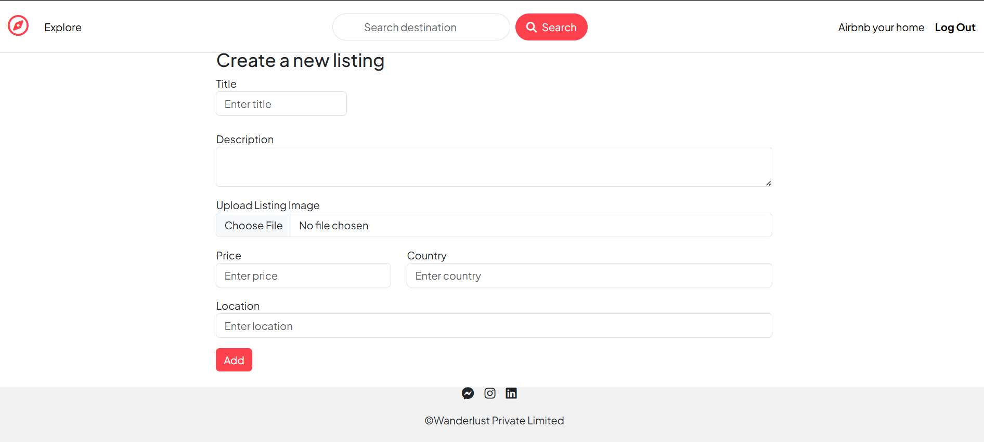

### **View Listings Page UI**

The **View Listings Page** displays all the active property listings available on the platform. The page shows each listing’s **title**, **image**, **price**, and **location**. Users can filter and search for properties based on their preferences such as **price range**, **location**, and **property type**.

Each listing is linked to a **detailed view page** where users can see more information, including reviews, ratings, and booking options. Listings are fetched from the **MongoDB database** and displayed dynamically using **EJS templates**. This page is optimized for **responsive design** using **Bootstrap**.

Here are three Listed Properties of the user given below

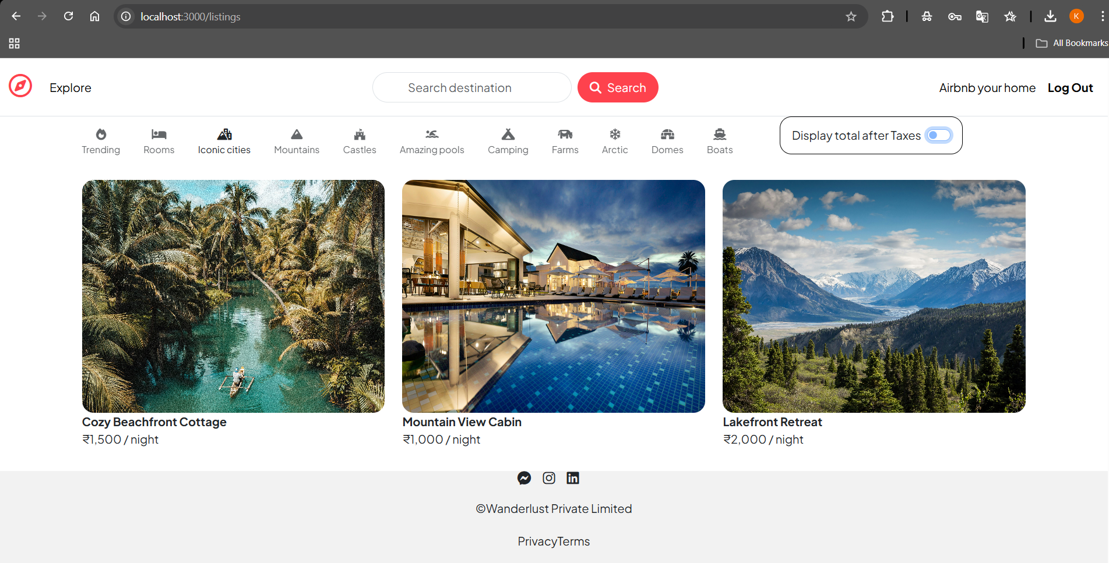

### **Listing Details Page UI**

The **Listing Details Page** shows detailed information about a single property. This includes the **property’s description**, **pricing**, **images**, and **host details**. Users can **rate** the property and leave reviews. The review system allows users to provide feedback on their experiences, which helps improve the platform's credibility.

Only registered and authenticated users can submit a review. This is managed through the **Passport.js authentication** system. The page also includes a **contact host** feature that allows users to send messages directly to the property owner for inquiries.

User can see the particular listing details and can enquire about that

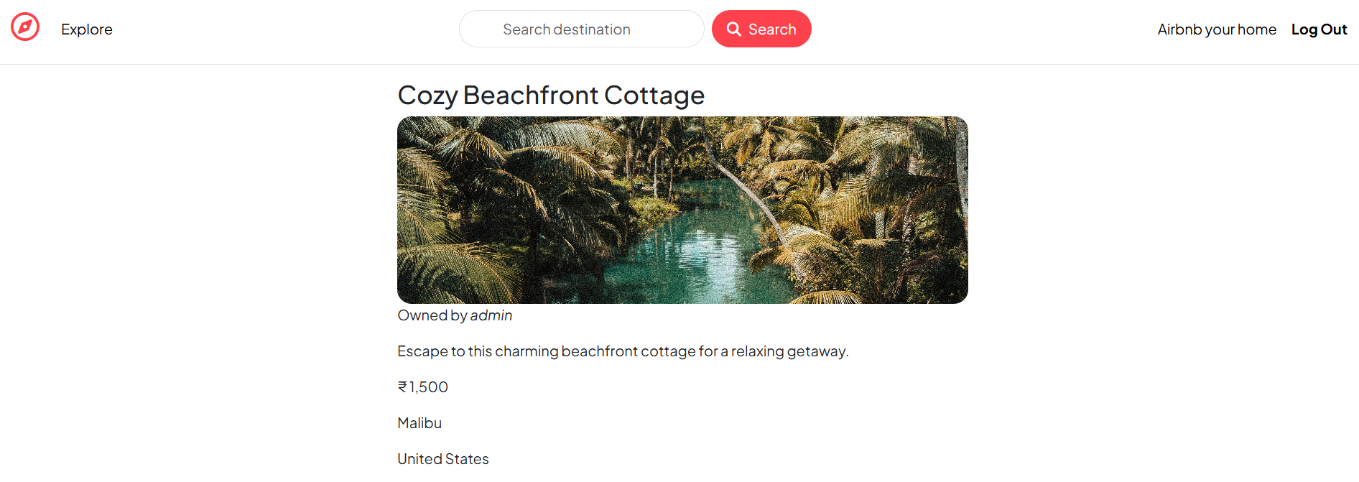

**UML Diagrams**

### **Use Case Diagram :**

A use case diagram is a visual representation of the interactions between a system and its users, also known as actors. It highlights the various ways a user can interact with the system to achieve specific goals, serving as a high-level overview of the system's functionality. These diagrams are crucial for understanding system requirements and ensuring all stakeholders have a shared understanding of how the system is intended to work.

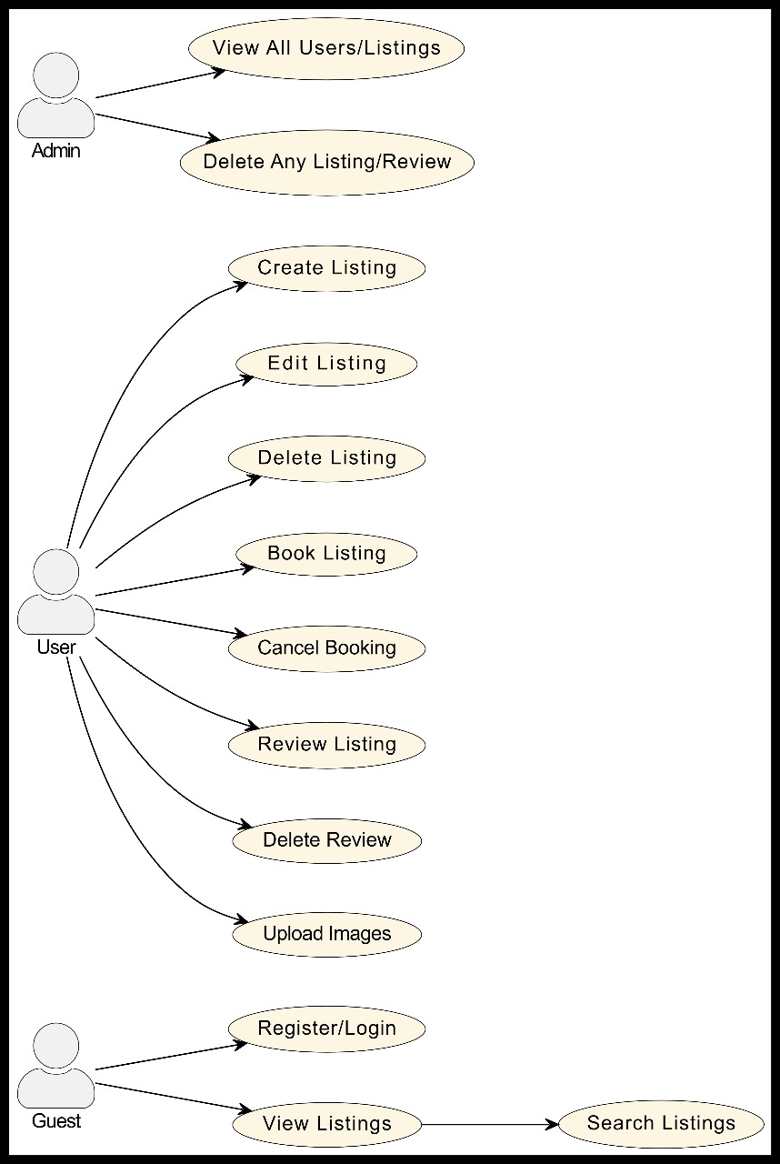

### **Activity Diagram:**

An activity diagram is a graphical representation of the flow of activities in a system or process. It's a type of flowchart that's used to model how a system should behave. Activity diagrams are also known as control flow diagrams or object flow diagrams.

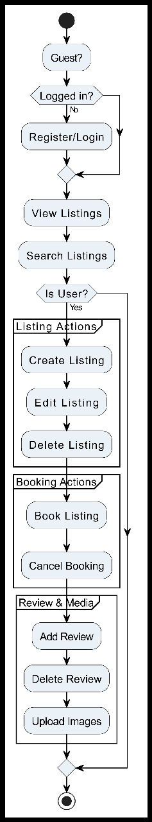

You can use activity diagrams to:

Model how activities are coordinated to provide a service

Model how a collection of use cases coordinate to represent business workflows

Describe the steps in a use case diagram

Reveal new information

Identify inefficiencies

Improve communication among stakeholders

### **Class Diagram:**

* How class diagrams are used
* Class diagrams are used to model the objects that make up a system
* They're used to display how objects relate to each other
* They're used to describe what objects do and the services they provide
* They're used to document software architecture
* They're used to generate source code

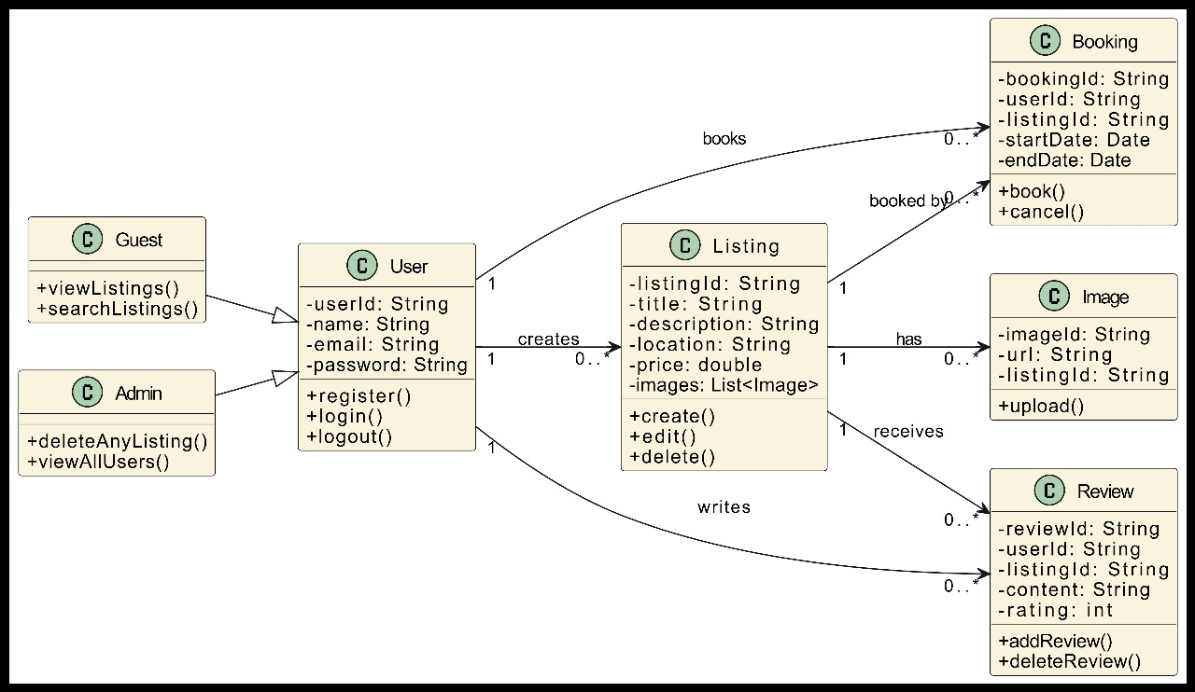

## **Sequence Diagram :**

A sequence diagram, a type of interaction diagram in Unified Modeling Language (UML), visually depicts the sequence of interactions between objects in a system over time. It shows the order in which messages are exchanged between objects, essentially illustrating how objects communicate and cooperate to achieve a specific task or process.

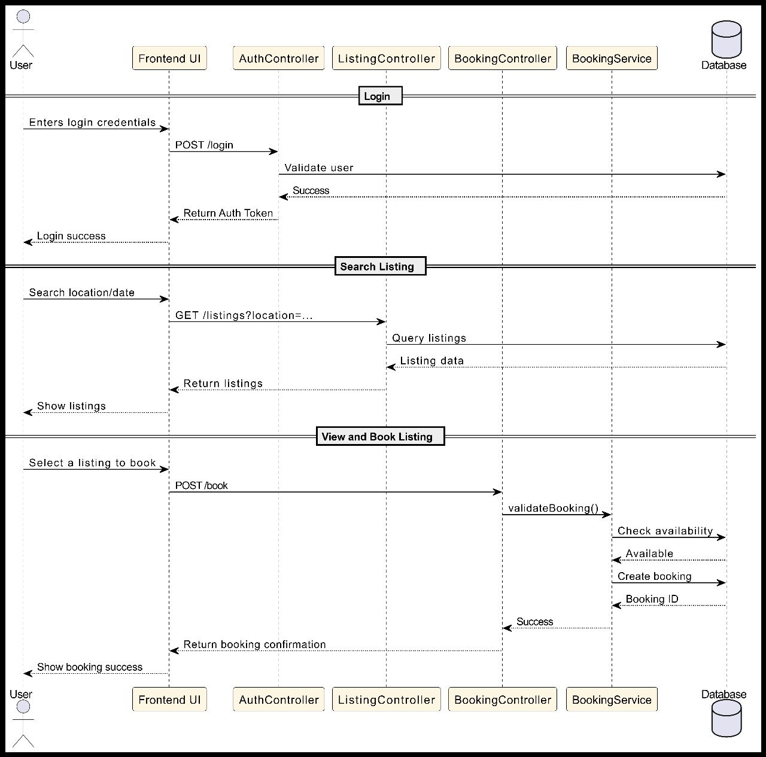

# References

* **Documents**:
* React Js Documentation
* Electron Js Documentation
* Typescript Documentation
* Node Js Documentation
* MongoDB Documentation
* **Websites**:
* Aptologics Pvt Ltd About Us., Mission, Vision, Logo, etc... Retrieved from

<https://www.aptologics.com/>

* <https://react.dev/reference/react>
* <https://www.typescriptlang.org/docs/handbook/typescript-in-5-minutes.html>
* <https://www.electronjs.org/docs/latest/tutorial/tutorial-first-app>
* <https://nodejs.org/docs/latest/api/assert.html>

# Mentor’s Feedback (Company Feedback)